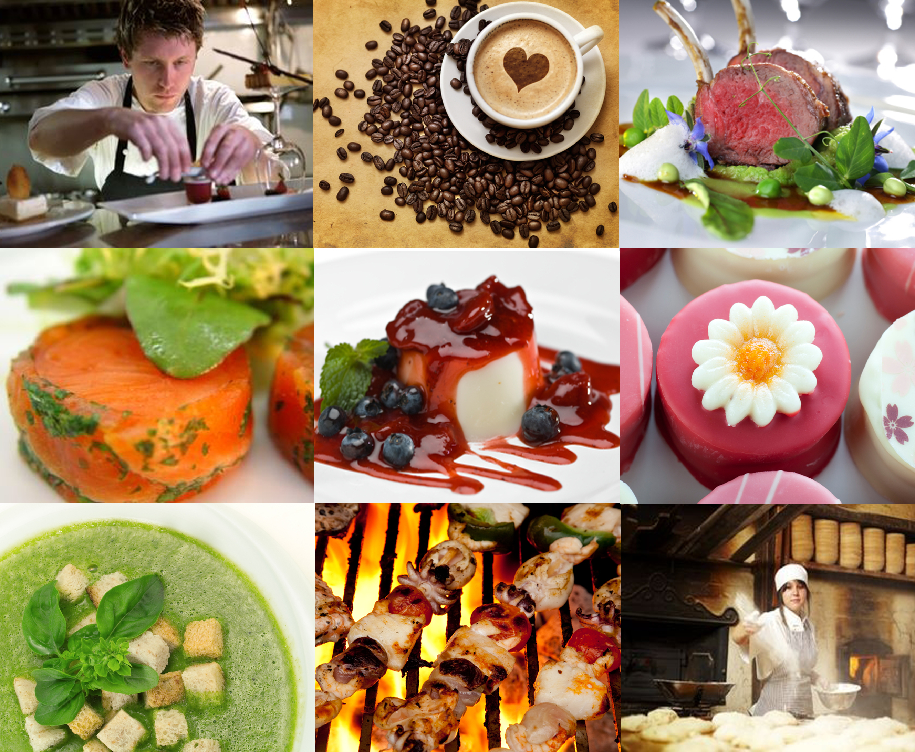



Prepare and cook seafood
D1.HCC.CL2.10
Trainee Manual





Prepare and cook seafood

D1.HCC.CL2.10

Trainee Manual





Project Base
William Angliss Institute of TAFE
555 La Trobe Street
Melbourne 3000 Victoria
Telephone: | (03) 9606 2111
Facsimile: | (03) 9670 1330
Acknowledgements
Project Director: | Wayne Crosbie
Chief Writer: | Alan Hickman
Subject Writer: | Garry Blackburn
Project Manager: | Alan Maguire
Editor: | Jim Irwin
DTP/Production: | Daniel Chee, Mai Vu, Kaly Quach

The Association of Southeast Asian Nations (ASEAN) was established on 8 August 1967. The Member States of the Association are Brunei Darussalam, Cambodia, Indonesia, Lao PDR, Malaysia, Myanmar, Philippines, Singapore, Thailand and Viet Nam.
The ASEAN Secretariat is based in Jakarta, Indonesia.
General Information on ASEAN appears online at the ASEAN Website: www.asean.org.
All text is produced by William Angliss Institute of TAFE for the ASEAN Project on “Toolbox Development for Front Office, Food and Beverage Services and Food Production Divisions”.
This publication is supported by the Australian Government’s aid program through the ASEAN-Australia Development Cooperation Program Phase II (AADCP II).
Copyright: Association of Southeast Asian Nations (ASEAN) 2013.
All rights reserved.
Disclaimer
Every effort has been made to ensure that this publication is free from errors or omissions. However, you should conduct your own enquiries and seek professional advice before relying on any fact, statement or matter contained in this book. The ASEAN Secretariat and William Angliss Institute of TAFE are not responsible for any injury, loss or damage as a result of material included or omitted from this course. Information in this module is current at the time of publication. Time of publication is indicated in the date stamp at the bottom of each page.
Some images appearing in this resource have been purchased from stock photography suppliers Shutterstock and iStockphoto and other third party copyright owners and as such are non-transferable and non-exclusive. Clip arts, font images and illustrations used are from the Microsoft Office Clip Art and Media Library. Some images have been provided by and are the property of William Angliss Institute.
Additional images have been sourced from Flickr and SKC and are used under Creative Commons licence: http://creativecommons.org/licenses/by/2.0/deed.en
File name: TM_Prepare_&_cook_seafood_FN_070114





Table of Contents
Introduction to trainee manual 1
Unit descriptor 3
Assessment matrix 5
Glossary 7
Element 1: Identify and select fish varieties 9
Element 2: Identify and select shellfish varieties 21
Element 3: Prepare fish and shellfish 31
Element 4: Cook and present seafood 41
Element 5: Store fish and shellfish to enterprise requirements 67
Presentation of written work 73
Recommended reading 75
Trainee evaluation sheet 77
Trainee Self-Assessment Checklist 79

Introduction to trainee manual

To the Trainee
Congratulations on joining this course. This Trainee Manual is one part of a ‘toolbox’ which is a resource provided to trainees, trainers and assessors to help you become competent in various areas of your work.
The ‘toolbox’ consists of three elements:
- A Trainee Manual for you to read and study at home or in class
- A Trainer Guide with Power Point slides to help your Trainer explain the content of the training material and provide class activities to help with practice
- An Assessment Manual which provides your Assessor with oral and written questions and other assessment tasks to establish whether or not you have achieved competency.
The first thing you may notice is that this training program and the information you find in the Trainee Manual seems different to the textbooks you have used previously. This is because the method of instruction and examination is different. The method used is called Competency based training (CBT) and Competency based assessment (CBA). CBT and CBA is the training and assessment system chosen by ASEAN (Association of South-East Asian Nations) to train people to work in the tourism and hospitality industry throughout all the ASEAN member states.
What is the CBT and CBA system and why has it been adopted by ASEAN?
CBT is a way of training that concentrates on what a worker can do or is required to do at work. The aim is of the training is to enable trainees to perform tasks and duties at a standard expected by employers. CBT seeks to develop the skills, knowledge and attitudes (or recognise the ones the trainee already possesses) to achieve the required competency standard. ASEAN has adopted the CBT/CBA training system as it is able to produce the type of worker that industry is looking for and this therefore increases trainees’ chances of obtaining employment.
CBA involves collecting evidence and making a judgement of the extent to which a worker can perform his/her duties at the required competency standard. Where a trainee can already demonstrate a degree of competency, either due to prior training or work experience, a process of ‘Recognition of Prior Learning’ (RPL) is available to trainees to recognise this. Please speak to your trainer about RPL if you think this applies to you.
What is a competency standard?
Competency standards are descriptions of the skills and knowledge required to perform a task or activity at the level of a required standard.
242 competency standards for the tourism and hospitality industries throughout the ASEAN region have been developed to cover all the knowledge, skills and attitudes required to work in the following occupational areas:
- Housekeeping
- Food Production
- Food and Beverage Service
- Front Office
- Travel Agencies
- Tour Operations.
All of these competency standards are available for you to look at. In fact you will find a summary of each one at the beginning of each Trainee Manual under the heading ‘Unit Descriptor’. The unit descriptor describes the content of the unit you will be studying in the Trainee Manual and provides a table of contents which are divided up into ‘Elements’ and ‘Performance Criteria”. An element is a description of one aspect of what has to be achieved in the workplace. The ‘Performance Criteria’ below each element details the level of performance that needs to be demonstrated to be declared competent.
There are other components of the competency standard:
- Unit Title: statement about what is to be done in the workplace
- Unit Number: unique number identifying the particular competency
- Nominal hours: number of classroom or practical hours usually needed to complete the competency. We call them ‘nominal’ hours because they can vary e.g. sometimes it will take an individual less time to complete a unit of competency because he/she has prior knowledge or work experience in that area.
The final heading you will see before you start reading the Trainee Manual is the ‘Assessment Matrix’. Competency based assessment requires trainees to be assessed in at least 2 – 3 different ways, one of which must be practical. This section outlines three ways assessment can be carried out and includes work projects, written questions and oral questions. The matrix is designed to show you which performance criteria will be assessed and how they will be assessed. Your trainer and/or assessor may also use other assessment methods including ‘Observation Checklist’ and ‘Third Party Statement’. An observation checklist is a way of recording how you perform at work and a third party statement is a statement by a supervisor or employer about the degree of competence they believe you have achieved. This can be based on observing your workplace performance, inspecting your work or gaining feedback from fellow workers.
Your trainer and/or assessor may use other methods to assess you such as:
- Journals
- Oral presentations
- Role plays
- Log books
- Group projects
- Practical demonstrations.
Remember your trainer is there to help you succeed and become competent. Please feel free to ask him or her for more explanation of what you have just read and of what is expected from you and best wishes for your future studies and future career in tourism and hospitality.

Unit descriptor
Prepare and cook seafood
This unit deals with the skills and knowledge required to Prepare and cook seafood in a range of settings within the hotel and travel industries workplace context.
Unit Code:
D1.HCC.CL2.10
Nominal Hours:
35 hours

Element 1: Identify and select fish varieties
Performance Criteria
1.1 Identify a selection of fish varieties
1.2 Identify commercial cuts of fish for menus
1.3 Identify and select suppliers for purchasing of products
1.4 Minimise wastage through correct purchasing
1.5 Identify costs through yield testing

Element 2: Identify and select shellfish varieties
Performance Criteria
2.1 Identify shellfish varieties
2.2 Identify commercial cuts of shellfish for menus
2.3 Identify and select suppliers for purchasing of products
2.4 Minimise wastage through correct purchasing
2.5 Identify costs through yield testing

Element 3: Prepare fish and shellfish
Performance Criteria
3.1 Prepare and portion fish and shellfish products to enterprise requirements
3.2 Minimise wastage/trimmings through appropriate preparation and storage
3.3 Identify and use correct equipment
3.4 Hold and kill live seafood humanely and to regulations

Element 4: Cook and present seafood
Performance Criteria
4.1 Select appropriate cooking method to fish variety and cuts
4.2 Prepare and cook following standard recipes within a commercial environment
4.3 Hold prepared products as required prior to presenting
4.4 Present fish and shellfish, including slice/carve and portion size
4.5 Prepare garnishes, sauces and accompaniments for fish and shellfish dishes

Element 5: Store fish and shellfish to enterprise requirements
Performance Criteria
5.1 Fresh and/or Cryovac items are stored correctly
5.2 Prepare and maintain correct thawing of fish and shellfish
5.3 Fish and shellfish are appropriately stored in correct containers
5.4 Fish and shellfish are correctly labelled
5.5 Ensure correct conditions are maintained for freshness and quality

Assessment matrix
Showing mapping of Performance Criteria against Work Projects, Written Questions and Oral Questions
The Assessment Matrix indicates three of the most common assessment activities your Assessor may use to assess your understanding of the content of this manual and your performance – Work Projects, Written Questions and Oral Questions. It also indicates where you can find the subject content related to these assessment activities in the Trainee Manual (i.e. under which element or performance criteria). As explained in the Introduction, however, the assessors are free to choose which assessment activities are most suitable to best capture evidence of competency as they deem appropriate for individual students.
 |  |  | Work Projects | Written Questions | Oral Questions
Element 1: Identify and select fish varieties
1.1 | Identify a selection of fish varieties |  | 1.1 | 1, 2, 3,  4, 5, | 1
1.2 | Identify commercial cuts of fish for menus |  | 1.1 | 6 | 2
1.3 | Identify and select suppliers for purchasing of products |  | 1.2 | 7 | 3
1.4 | Minimise wastage through correct purchasing |  | 1.3 | 8 | 4
1.5 | Identify costs through yield testing |  | 1.3 | 9 | 5
Element 2: Identify and select shellfish varieties
2.1 |  | Identify shellfish varieties | 2.1 | 10, 11, 12, | 6
2.2 |  | Identify commercial cuts of shellfish for menus | 2.1 | 13, 14 | 7
2.3 |  | Identify and select suppliers for purchasing of products | 2.2 | 15 | 8
2.4 |  | Minimise wastage through correct purchasing |  | 16 | 9
2.5 |  | Identify costs through yield testing | 2.3 | 17, 18 | 10
Element 3: Prepare fish and shellfish
3.1 | Prepare and portion fish and shellfish products to enterprise requirements |  | 3.1 | 19, 20, 21 | 11
3.2 | Minimise wastage/trimmings through appropriate preparation and storage |  | 3.2 | 22 | 12
3.3 | Identify and use correct equipment |  | 3.3 | 23 | 13
3.4 | Hold and kill live seafood humanely and to regulations |  | 3.4 | 24 | 14
Element 4: Cook and present seafood
4.1 |  | Select appropriate cooking method to fish variety and cuts | 4.1 | 25, 26 | 15
4.2 |  | Prepare and cook following standard recipes within a commercial environment | 4.1 | 27 | 16
4.3 |  | Hold prepared products as required prior to presenting | 4.1 | 28 | 17
4.4 |  | Present fish and shellfish, including slice/carve and portion size | 4.1 | 29 | 18
4.5 |  | Prepare garnishes, sauces and accompaniments for fish and shellfish dishes | 4.2 | - | 19
Element 5: Store fish and shellfish to enterprise requirements
5.1 | Fresh and/or Cryovac items are stored correctly |  | 5.1 | 30 | 20
5.2 | Prepare and maintain correct thawing of fish and shellfish |  | 5.2 | 31 | 21
5.3 | Fish and shellfish are appropriately stored in correct containers |  | 5.3 | 32 | 22
5.4 | Fish and shellfish are correctly labelled |  | 5.3 | 33 | 23
5.5 | Ensure correct conditions are maintained for freshness and quality |  | 5.4 | 34 | 24

Glossary
Term | Explanation
Anguille | French name for Eel
Bisque | Soup or sauce made from shell of lobsters or other crustaceans
Bouillabaisse | A types of fish stew or soup from the Marseille area of France
Cephalopods | soft bodied animal from ocean, no skeleton
Courts Bouillons | Acidic aromatic poaching liquid for cooking fish
Crayfish | Fresh water crustacean, will have claws like crab, lobster is saltwater crustacean
Darne | Cutlet or steak cut through the bone of round fish with portion of both fillets attached
Delice | French name for small fillet that is folded before cooking
Flat fish | Fish that will yield 4 fillets
Fumet de Poisson | Concentrated fish stock
Gutting | Removal of the internal organs of the fish
Lobster | Lobster is saltwater crustacean, Crayfish is fresh water; similar body shape
Matelote | A type of fish stew, French in origin, from the word for sailor, not like bouillabaisse which is from Marseilles area of France
Moules | French name for mussels
Paella | Spanish dish made from m rice and seafood
Paupiette | A thin fillet or portion that has been flattened, covered with farce and rolled then poached
Prawn | Small animal with outer shell that lives in water
Round fish | Fish that will yield 2 fillets
Scaling | Term used to describe the action of removing fish scales
Scoring | Cutting thick parts of the fillet on whole fish to speed up the cooking process. Minimises overcooking of thin portions of flesh
Shellfish | Animals other than fish that have an outer shell around their flesh that live in water
Smell of the Sea | Term used to describe the smell of quality seafood; if it smells fishy then it is not at its freshest
Supreme | Cut portion from the fillet of a fish

Element 1:
Identify and select fish varieties

1.1 Identify a selection of fish varieties

Categories of Fish
Useful site in Malaysia for available seafood species:
- http://noeyeddeer.com/fish/fish-species-identification-guide.html.
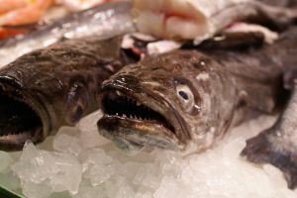
Salt Water
- Harvested from the sea
- Many are now farmed due to declining fish stocks in the world. Large scale commercial fishing has been found to be harmful to stock levels. Many countries are now participating in quotas to try to sustain minimum levels in the oceans
- Problems arising from catching under-grown/under-developed seafood that are too small for use in cooking such as baby crabs and young fish or catching fish before their spawning seasons.
Fresh Water
- Name will change from country to country.
Colour of flesh
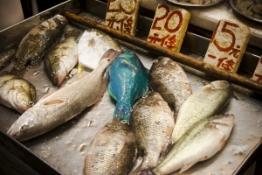
Fish are also categorised into types and colour of the flesh:
- White Flesh
- Oily (Dark) Flesh.
Shape
- Round
- Flat.

White Flesh Fish (Saltwater)
Barramundi
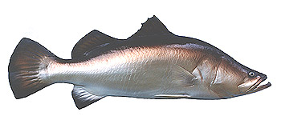
Wild barramundi is revered for its flavour. Can be fresh water or salt water depending on age.
Known by several name such as Sea Bass; Asian Sea bass and is found throughout the Indian and Pacific Ocean regions where it can grow up to 60 kg.
Farmed barramundi can be purchased as baby barramundi plate size 400-600gm.
White coloured flesh; distinctive mild flavour.

Flake
Shark meat; Firm flesh with distinct flavour. Economical large flesh from each fish.
Pinkish raw in colour can have a darker flesh when cooked and can have a fishy flavour.
Versatile and budget priced. Low fat content.
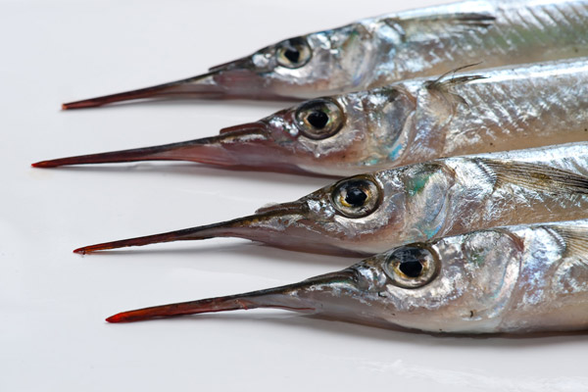
Garfish
Small slender fish with a distinctive spear nose; with low yield.
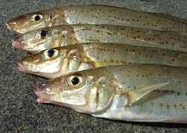
Can be cooked whole or filleted. Flesh is mild tasting with many fine bones which can be eaten. Low to medium fast content.
Whiting
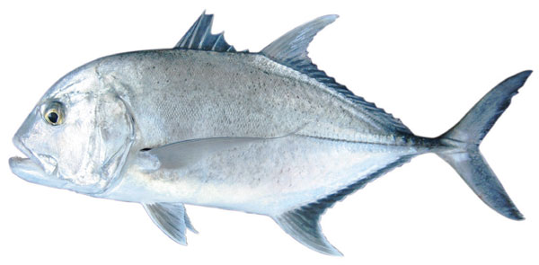
White flesh with a delicate flavour. Small thin fillets with low fat content.
Trevally
Darker flesh which turns white when cooked.
Ling
Densely textured fish with fresh white flesh that holds shape when cooked.
Low to medium fat content, with mild to bland tasty fish.
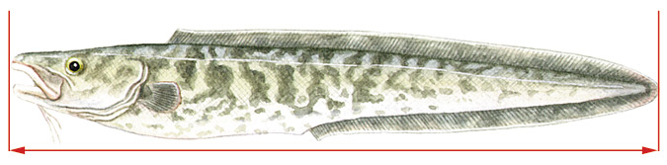
Lings have proven to be popular species for home and commercial cooking because of the large, boned-out fillets and thick steaks, which hold their shape well in cooking.
They are lovely tasting fishes with many uses, well suited to grilling, frying, barbecuing and baking. Try baking with a crust of brioche, thyme and lemon zest or prepare as kebabs.

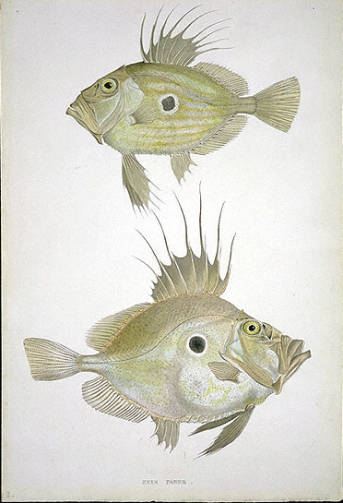
Dory
John Dory is regarded as the best and is the most expensive but Silver and Mirror dory are also excellent tasting fish.
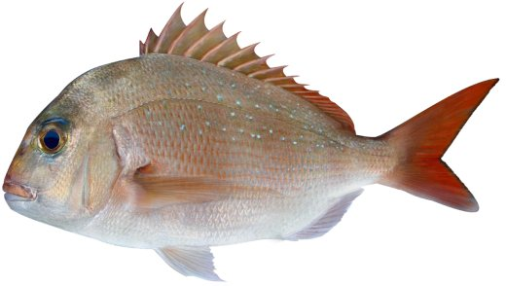
Delicate mild to sweet flavour white flesh that is firm to tender in texture. Versatile can be poached, grilled, steamed or baked.
Snapper
Part of bream family with white to pinkish flesh. Textured medium flakes with low fat content; delicate sweet mild flavour.
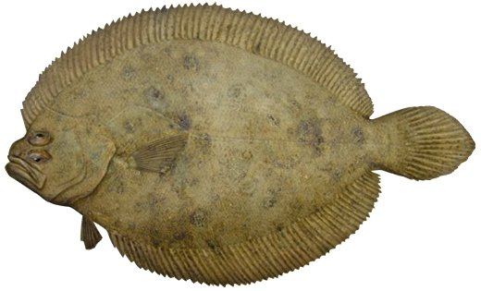
Flounder
Flat fish, can be served whole or filleted; 4 small fillets.
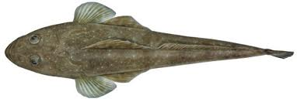
Flathead
A flat fish with 2 distinct fillets, which can be fried or baked; distinctive mild flavour; 40% loss in weight when filleted.
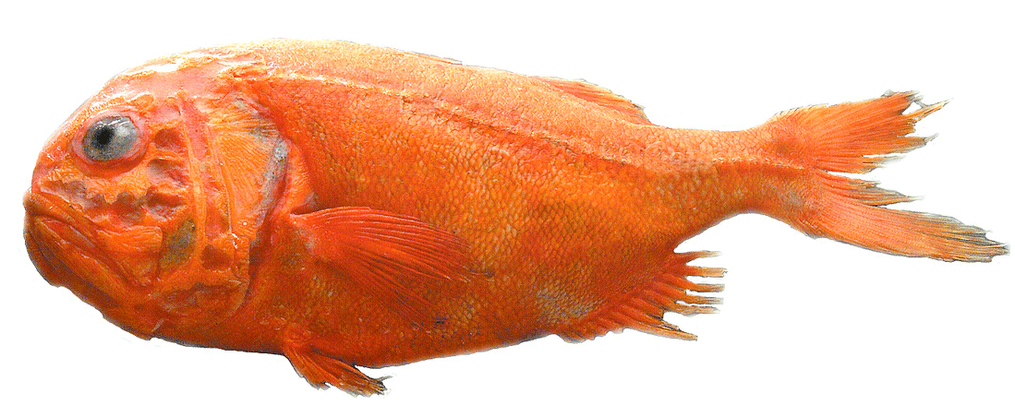
Orange Roughy
Deep sea fish; slow growing; pearly white flesh with medium to high fat content.
Texture is medium to firm; taste is mild but because of high fat content it can taste rich.

Dark Oily Fish (Saltwater)
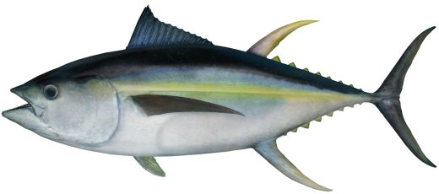
Tuna
Yellow Fin, Big eye, Southern Blue fin, Albacore and Bonito are just some of the names that refer to tuna; Pink to red flesh with low to high fat content; rich in flavour, best cooked rare.
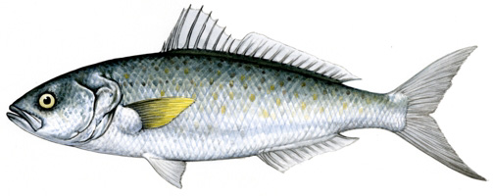
Salmon
Dark flesh with a strong meaty flavour suited to smoking, baking or made into fish cakes; Different to Atlantic salmon; strong flavour, fishy flavour; course to medium texture.
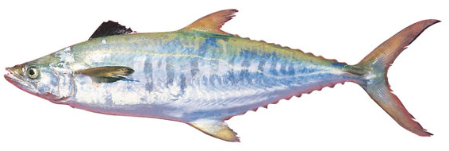
Mackerel
Like their close cousins the tuna, they’re prized for their meaty, oily flesh; School Mackerel have a strong flavour with high oil content. Spanish Mackerel has much less oil content, and is the lighter flavoured variety of the species.
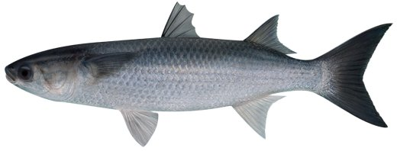
Mullet
Rich, strong fishy flavour which is quite distinctive depending on the species; high oil content.

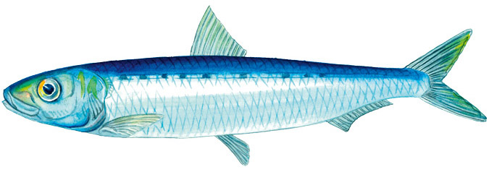
Pilchard (Sardine)
Dark oily fish; young pilchards are referred to as Sardines; sourced from all over the world.
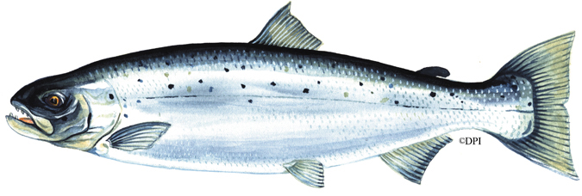
Atlantic salmon
Pink orange in colour; medium size flakes; very high fat content; mild distinctive flavour; Purchased fresh or smoked.

Freshwater varieties
Names change from country to country. Food sustainability has meant that many are now farmed by modern Aquaculture methods.
Speak to local suppliers regarding names of fish, how do they eat, colour of flesh and suitable sizes. Most are harvested at plate size.

1.2 Identify commercial cuts of fish for menus

Introduction
Commercial cuts of fish should include classical and contemporary cuts of fish and relate to:
Menu needs
Is the main theme of the restaurant seafood or is fish just offered as an alternative to other meats.
Is the fish being served whole or cut into portions?
Portions may be either:
- Darne or cutlets
- Supremes or portion of the fillet
- Fillet – one side of the fish
- Paupiette – a thin fillet that is rolled
- Delice – small fillet that is folded
- Goujon – strips of fish cut across the fillet
- Goujonette – small strips of fish flesh used for finger food.
Cooking Methods
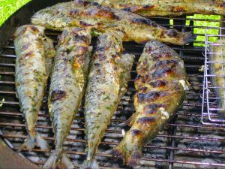
Fish can be:
- Poached
- Grilled
- Fried
- Deep
- Shallow
- Steamed
- Baked in paper, banana leaf or pastry (en papillote).
Fish varieties
Varieties of fish are similar all around the world.

Varieties can be controlled by water temperature and available food. Some species might be found in Pacific and Indian oceans because the waters join where water temperatures are moderate.

Atlantic Salmon are different species to the Pacific salmon which is found on the coastlines of North West Canada and Alaska.
Australian Salmon are different again.
Students need to develop knowledge of the fish that are in their area of working.
- Season availability
- Price
- Availability to the market:
- Fresh
- Frozen.

Portion size
When whole fish are served they are generally shared by several people. Larger fish are cut into portions. Average portion sizes are 150 gm – 200 gm cleaned flesh weight.
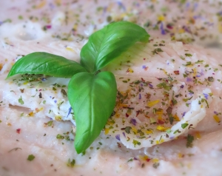
Smaller fish can be steamed or deep fried to customer preference.
Baby barramundi are now farmed to approximately 400 gm.
These are considered plate size for people and restaurants that consume whole fish.
Whole fish are popular in Asian Cuisines but it is not a 'single' serve. It is a shared plate.

1.3 Identify and select suppliers for purchasing of products

Introduction

Select suppliers may be related to:
Choosing a supplier for the enterprise is important.
The questions that has to be asked and answered:
- Can they supply what is required?
- Is the price acceptable?
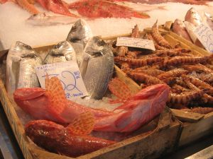
Ethical questions might need to be answered if it is important to customers is where the product is sourced:
- Local
- Imported from overseas
- What is reliability of supply?
- Is the quality up to the standard required?
Environmental issues
It is important to consider that problems may arise due to pollution and environmental safety concerns.
For example water pollution or water which may be inhabited by sea animals that could have an adverse effect on the safety of consumers.
Where and how suppliers obtain their fish is just as important as the types and quantities of fish available.
Delivery requirements
Can product be purchased in quantities that suit the enterprise needs?
If larger quantities have to be ordered to meet minimum purchase requirements:
- Can we store excess until needed?
- Cost of storage versus savings by buying in bulk?
Cost, trading terms
Cost of purchasing can sometimes be prohibitive to the income stream of the enterprise.

How long before the goods have to be paid for?
- 7 days
- 30 days
- 90 days.
Or does the enterprise have to pay cash when product is delivered.
Relationship
If the supplier only deals with large customer purchases alternative suppliers might need to be found.
The size of the enterprise will relate to the size of the supplier.
Can product be purchased straight from the fisherman?
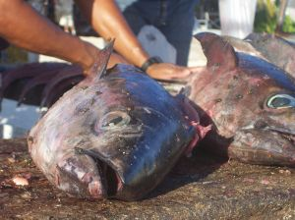
How is purchased?
- Freshly caught
- Processed;
- Clean
- Gutted
- Portioned.
How seafood is brought into the establishment will determine the skills needed by the staff to process the product when it comes into the kitchen.
Is there area or space to clean seafood?
Lots of water and easily washable workspaces, walls and floor, are needed to clean seafood.
Product range/variety
What is the variety that is required by the restaurant?
- Whole fish
- Fresh fish
- Portioned fish
- Frozen fish
- Shellfish.
Or maybe just need one type of fish for the one dish that is offered as an alternative to the other dishes on the menu.
It may be more efficient to purchase seafood into place of business ready portioned, fresh or frozen.
What is best for the business?

1.4 Minimise wastage through correct purchasing
Storage space available
The most important point when purchasing is can this quantity be stored within the confines of the premises of the enterprise.
- Do not purchase frozen fish if it needs to be stored for 3 days frozen before being used and there is no freezer in the kitchen
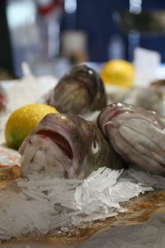
- Do not purchase 100 live fish if the equipment for holding live fish is not available.
Volume requirements, such as a la carte, functions and specials
Can the volume purchased be utilised efficiently?
Are your suppliers able to supply with the amount required?
Is there sufficient space to deal with amount required?
First In, First Out (FIFO)
All product needs to go through the store area on a first in, first out basis. (FIFO)
This allows for all stock to be used in an efficient manner.
Receiving times, as needed
Purchasing stock ‘as needed’ is the preferred method of purchasing in the modern area as it keeps cash flow to maximum and cash held in stock to a minimum.
As needed needs to be defined as how many days before stock is needed is it bought into the stores area.
Two days is optimal time.
This allows for any processing preparation to take place. In larger premises where large volumes of food are required.

Quality points in purchasing fish
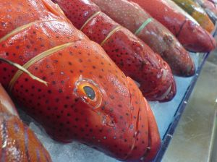
When purchasing fresh seafood certain points need to be looked at to tell purchasers if the seafood is freshest available.
When purchasing whole fish, purchaser needs to look at the following:
Smell of the fish: It should smell of the sea, not fishy
Appearance: Should be bright and have a sheen
Eyes: Eyes need to be bright and shiny, not sunken into socket
Scales: Scales should be still attached and attached to fish firmly
Gills: Gills will be brightly coloured if it is fresh

1.5 Identify costs through yield testing

Introduction
Yield Testing
Yield testing is about how many serves are able to be obtained from a set amount of product. Yield testing is important to ensure profit margins are acceptable.

Fish
How big is the fish? Fish from the wild are notoriously unpredictable to the marketplace. They can all be different sizes.
Aquaculture; Fish farming; where sizes can be monitored and harvested when they are at a certain age allows for more predictability.
How does the enterprise wish to market their menu products?
Whole fish
If whole fish are on the menu then what needs to be sourced are fish that are all the same size.
Fillet
Single fillets are fine but still need fish all the same size.
Supremes
Portion of a fillet of fish at a specific weight. Easier to do but then how are the off cuts going to be utilised.
Filleting and skinning
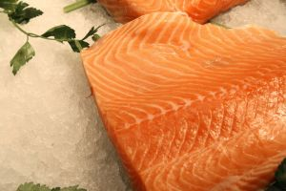
Some fish species are quite large and lend themselves to being portioned:
- Cutlets are the cheapest form of portioning but sizes change as the fish is cut
- Supremes are portioned from the fillet; skin on or skin off
- Goujons are strips of fish fillets; easy to portion control sizes
- Goujonettes; thinner and smaller than Goujons; finger food portions.
Skin or no skin
Skin can be removed as it can be tough and chewy.
Fish can be grilled skin down to crisp the skin and add crunch to texture of the dish; customer then decides if they wish to consume the skin.

Portion weights
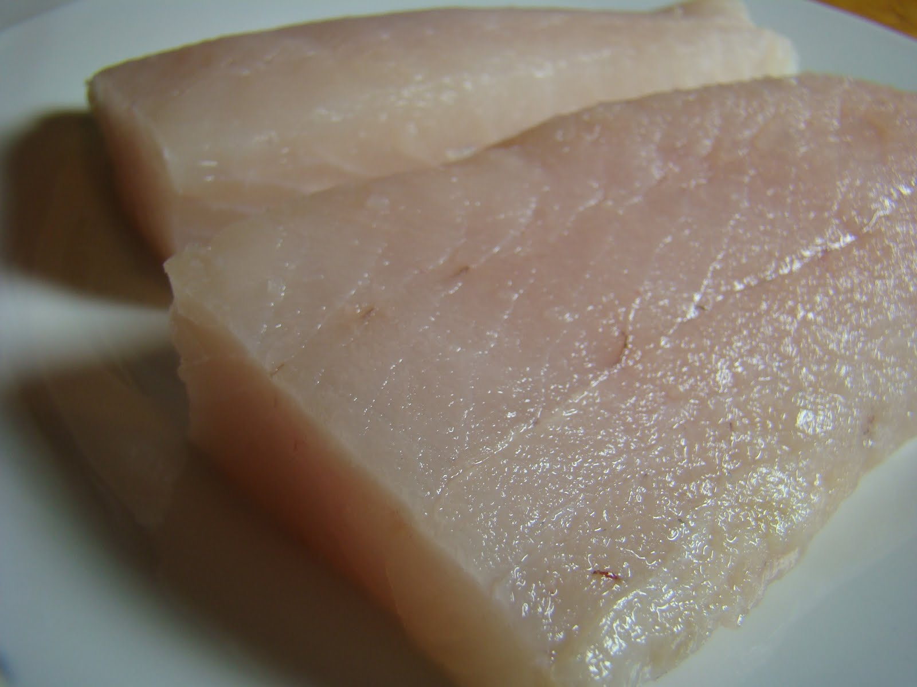
While whole fish costing can be sold by the weight of the live fish; not all restaurants wish to carry the heavy infrastructure cost of maintaining live fish tanks.
In some cultures it is acceptable to see the fish being extracted from the live tank display and serving the fish 20 minutes later at the table.
Larger fillets are easiest to portion to specific weights:
- Entrée size 80 gm-100 gm
- Main course size 150 gm-180 gm.
But off cuts need to be utilised or discarded.
If discarded then wastage needs to be measured and cost of wastage applied to number of portions.

Off-cut usage
When cleaning and portioning whole fish into specific weights and portion size brings its own issue of what to do with fish off-cuts.
Can off cuts be utilised within the establishment.
Larger establishments may be able to send to other kitchens to be utilised in other menu items.

Staff skills
Less processing required equals fewer skills required in the kitchen.
If fish are purchased ready portioned for cooking then the skill level of the cooks does not have to be as accomplished.
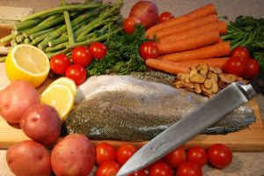
The biggest problem with this is that if fish are not able to be sourced cleaned and portioned and the cook is then expected to have this skill then quality will be diminished due to level of skill.
When there is plenty of business and work available then people can be streamlined into fewer jobs or menu items.
Skill sets may need to be maintained.
Opportunity keeps skill levels need to be maintained.

Work Projects
It is a requirement of this Unit you complete Work Projects as advised by your Trainer.
You must submit documentation, suitable evidence or other relevant proof of completion of the project by the agreed date.
The student needs to submit a plan or a report on the following requirements that are listed here and through the manual.
The student will need to produce a suitable number of dishes to prove that the leaning elements can be met.
Suggested that 6 seafood dishes are completed
  - Choose the variety of fish needed to meet the following criteria:
- Identify both round fish and flatfish available in the local market available for the enterprise to use
- Round fish for filleting
- Round fish for cutlets
- Flat fish for filleting.
1.2. Which supplier will most suit the enterprise best and why you chose this supplier?
1.3. Costing for each cut of fish per portion:
- Yield test will have to be substantiated with written evidence.

Summary

Identify and select fish varieties
Identify a selection of fish varieties
- What are the names of the varieties of fish available to the marketplace?
- How can they be utilised on the menu?
Identify commercial cuts of fish for menus
- Decision on how fish is going to be presented on the menu needs to be established.
Identify and select suppliers for purchasing of products
- What is going to be the best supplier to suit the needs of the business?
- Easy access to supplies
- Time period to wait for delivery
- Carrying of excess stock.
Minimise wastage through correct purchasing
- How can waste be minimised?
- What can be done with the leftovers and off cuts?
- Can the entire product be utilised before it becomes out of date?
- Order only what is required for the service period.
Identify costs through yield testing
- The cost of purchasing must be reflected in the cost the portion size served
- Fish may be $6 each but if yield is 2 fillets and only 45% of total weight of fish; what is the cost of each fillet portion?
- If the fish is 1 kg then cost of fillet is $3 per fillet.

Element 2:
Identify and select shellfish varieties

2.1 Identify shellfish varieties

Introduction
Shellfish varieties may relate to:
Crustaceans, such as jointed limb and hard exterior shell.
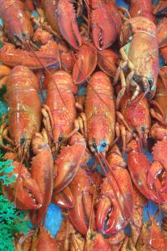
Shellfish categories
Crustaceans
- Hard shell exterior
- Exoskeletons; no internal skeleton
- Jointed limbs.
Crustacean examples
- Crabs; blue swimmer; mud
- Crayfish
- Lobster
- Yabby
- Bugs
- Prawns: Banana, King, Tiger.

Student Activity
What are the names of crustacean produce in your marketplace?
Students need to develop ongoing knowledge of what is available in their market place:
- What does it look like?
- How much does it cost?
- How is it prepared?
- Will it be popular?
- Can I make a profit from selling this on the menu?
Use the websites listed in Recommended Reading to obtain visual learning.

Molluscs
Soft bodied animal with protective shell.
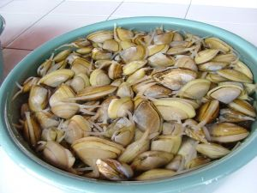
Molluscs Examples
Gastropods - 1 shell
- Abalone
Bivalve - 2 shells
- Mussels
- Oysters
- Scallops
- Pipis.

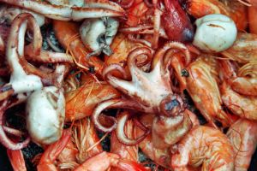
Cephalopods
Internal transparent bone (quill)
- Squid
- Cuttlefish
- Octopus
- Calamari.
All are classified as 'gastropods' and are found all over the world.

2.2 Identify commercial cuts of shellfish for menus
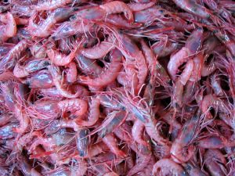
Shell fish; crustacean and molluscs can be purchased:
- Fresh
- Frozen
- Cooked
- In shell
- Meat only.
Decision needs to be made of what is going to be presented on the menu. This will determine how product will be purchased.
When decision is made on what is required then enterprise is able to approach the marketplace and purchase the commodity required.
Most crustaceans will be purchased whole in the shell.
- Live
- Not live
- Chilled
- Frozen.
Quality points to look for when purchasing Crustacean in any form is:
- Colour
- All body parts attached
- Shell is not cracked
- Smells fresh.
If purchasing live consideration should be given to how active the animal is. If there is not much movement then it is near death or dying. Lots of movement indicates it is healthy.

Molluscs
These can be purchased in the shell fresh or frozen. If purchased fresh then consideration needs to be allowed for time out of the water.
Size of shellfish will determine price and amount per serve.

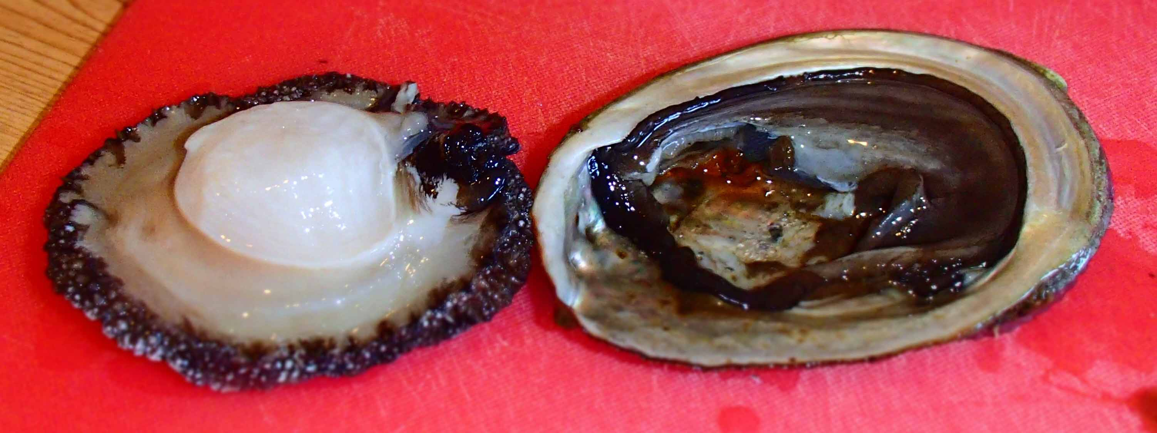
Abalone
Meat can be purchased and is sliced into thin pieces before being tenderised. Most are pan-fried.
Some recipes will call for meat to be minced and sold as burgers.

2.3 Identify and select suppliers for purchasing of products

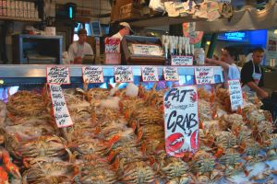
Introduction
Select suppliers may be related to:
Choosing a supplier for the enterprise is important.
The questions that has to be asked and answered:
- Can they supply what is required?
- Is the price acceptable?
Ethical questions might need to be answered if it is important to customers is where the product is sourced:
- Local
- Imported from overseas
- What is reliability of supply?
- Is the quality up to the standard required?
Delivery requirements
Can product be purchased in quantities that suit the enterprise needs?
If larger quantities have to be ordered to meet minimum purchase requirements:
- Can we store excess until needed?
- Cost of storage versus savings by buying in bulk.
Cost, trading terms
Cost of purchasing can sometimes be prohibitive to the income stream of the enterprise.
How long before the goods have to be paid for:
- 7 days
- 30 days
- 90 days.
Or does the enterprise have to pay cash when product is delivered.

Relationship
If the supplier only deals with large customer purchases alternative suppliers might need to be found.
The size of the enterprise will relate to the size of the supplier.
Can product be purchased straight from the fisherman?
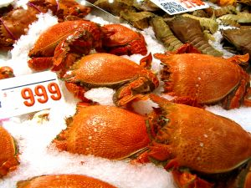
How is purchased?
- Freshly caught
- Processed:
- Meat only
- Meat and half shell
- Frozen.
How seafood is brought into the establishment will determine the skills needed by the staff to process the product when it comes into the kitchen.
Is there area or space to clean seafood?
Lots of water and easily washable workspaces, walls and floor, are needed to clean seafood.
Product range/variety
What is the variety that is required by the restaurant?
- Shellfish
- Crustacean
- Molluscs.
Or maybe just need one type of shellfish for the one dish that is offered as an alternative to the other dishes on the menu.
It may be more efficient to purchase seafood into place of business ready portioned, fresh or frozen.
What is best for the business?

2.4 Minimise wastage through correct purchasing
Storage space available
The most important point when purchasing is can this quantity be stored within the confines of the premises of the enterprise:
- Do not purchase frozen shellfish if it needs to be stored for 3 days frozen before being used and there is no freezer in the kitchen
- Do not purchase 100 live crayfish if the equipment for holding live crayfish is not available.
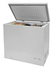
Volume requirements, such as a la carte, functions and specials
- Can the volume purchased be utilised efficiently?
- Are your suppliers able to supply with the amount required?
- Is there sufficient space to deal with amount required?
First In, First Out (FIFO)
All product needs to go through the store area on a first in, first out basis. (FIFO)
This allows for all stock to be used in an efficient manner.
Receiving times, as needed
Purchasing stock ‘as needed’ is the preferred method of purchasing in the modern area as it keeps cash flow to maximum and cash held in stock to a minimum.
As needed needs to be defined as how many days before stock is needed is it bought into the stores area:
- Two days is optimal time.
This allows for any processing preparation to take place. In larger premises where large volumes of food are required.

2.5 Identify costs through yield testing
Yield testing may include:
Portion weights
Shellfish is relatively easy to portion as most is purchased by the each as with Crayfish Lobster and Crabs or by the Kilo.
- If purchased by the 'each' then the only decision is how much per serve
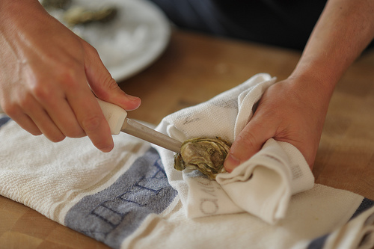
- If purchased by each then the decision has to be made regarding 'terms of sale'
- Sold by kilo; how heavy they are when taken from tank.
Off-cut usage
Can the shells of crayfish and lobster be utilised to make bisques sauce or soup.
Prawn heads used to make seafood sauce?
Staff skills
Do the staff have sufficient skills to handle and process shellfish humanely?
If the staff are not trained sufficiently to kill live seafood humanely and efficiently then result of this lack of skill will show up in dish being presented.
Small shellfish sold per serve
- Small pippis or clams are generally small; so many in plate but still needs to be measured
- Mussels generally measured by weight or volume.

Work Projects
It is a requirement of this Unit you complete Work Projects as advised by your Trainer.
You must submit documentation, suitable evidence or other relevant proof of completion of the project by the agreed date.
The student needs to submit a plan or a report on the following requirements that are listed here and through the manual.
The student will need to produce a suitable number of dishes to prove that the leaning elements can be met.
Suggest that 6 seafood dishes are completed. Of the 6 dishes 2 should be from shellfish varieties.
2.1 Choose the variety of shellfish needed to meet the following criteria:
- What is the name of the shellfish that will be cooked
- Name of the portion to be used
- Whole; Pieces.
2.2 Which supplier will most suit the enterprise best and why you chose this supplier:
- Why have you chosen this supplier?
2.3. Costing for each cut of shell fish per portion:
- Yield test will have to be substantiated with written evidence.

Summary

Identify and select shellfish varieties
Identify shellfish varieties
- Lobster; Prawns
- Students need to accumulate local knowledge of the name of crustacean in their area and marketplace.
Identify commercial cuts of shellfish for menus
- Most are sold whole in the shell
- Can be purchased frozen out of the shell
- What is the style of the enterprise?
- What are the requirements of the customers?
Identify and select suppliers for purchasing of products
- Ease of service
- Proximity to enterprise
- Terms of trade
- Continuity of supply.
Minimise wastage through correct purchasing
- Purchase only what you need for purchasing period
- Purchasing period for seafood should be daily.
Identify costs through yield testing
- Cost per serve will be determined by cost per kilo, size of serves.

Element 3:
Prepare fish and shellfish

3.1 Prepare and portion fish and shellfish products to enterprise requirements
Prepare and portion may relate to:
Scale, gut, scrape, fillet and skin.
Fish purchased fresh will have to be cleaned of all extraneous matter.
- This is unwanted matter in the final product.

Cleaning, Trimming and Preparing Fish and Shellfish
Fish
The majority of hotels, restaurants and other catering outlets will purchase fish which has been either partially or totally cleaned.
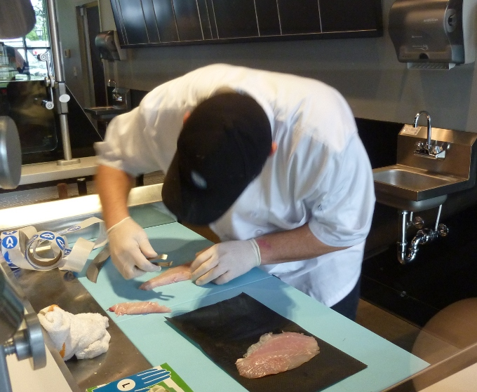
Fish can be purchased whole – i.e. just scaled and gutted, or filleted and skinned.
However it is an important skill to know how to clean and prepare fish from the sea or river, for the plate.
Once a fish has been caught, remove from its natural environment and is being transported to market, its quality is already beginning to deteriorate.
It is important to gut fish as soon as possible.
Filleting fish can be applied to both ROUND fish and FLAT fish.
- Round fish yield two fillets
- Flat fish yield four fillets.
Today however, we usually purchase fish which has been pre-filleted. Nevertheless it is a good skill to have.
To fillet a round fish
- Use a sharp knife. Lay the fish on its side and make an incision behind its gills, angled into the back of the head
- Cut along the backbone on the upper side of the dorsal fin, from head to tail. Carefully remove the fillet from the bone
- Turn the fish over and repeat to remove the other fillet
- Any ribcage bones can be removed by laying the fillet, skin side down, on a board
- Using your sharp knife, carefully remove the bones from the flesh, by cutting between the flesh and bones. Other bones throughout the flesh can be removed using fish tweezers.
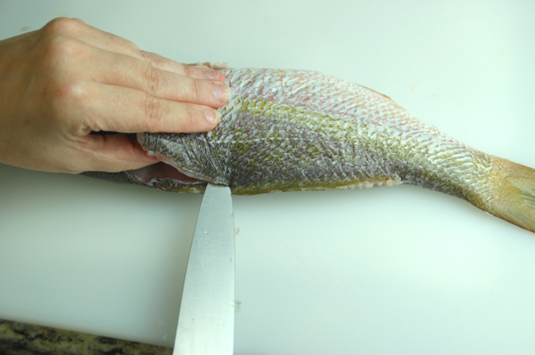
Removal of skin
If required, the skin can be removed from the fillets.
- Lay the fillet on the cutting board with skin side down and the tail nearest you
- Carefully make an incision between the skin and fillet, taking care not to cut through the skin
- Carefully work the blade of your knife back and forth between the skin and fillet, pushing and cutting towards the head end of the fillet, and pulling the skin towards yourself
- When the skin is off the fillet the fillet can now be portioned into supreme portions, both large and small.
Clean shells and shuck
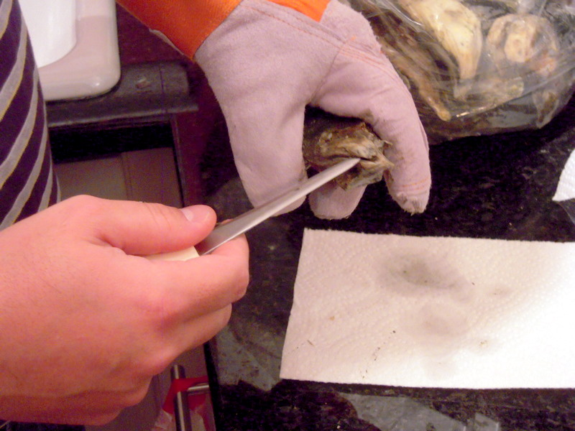
Cleaning of shellfish before service is important to rid the surface of the shell of any marine growth that has attached during the growing period.
Other marine life such as barnacles and seaweed may have attached themselves and must now be removed.
Mussels will have a beard that has to be removed.
Oysters will have to be shucked, remove cap half of shell, release from base shell, turnover then place back into base shell.
Keep chilled until service.
Oysters can be served in the half shell or just as meat in various dishes. Do not overcook.
Slice, dice, skewer, smoke, marinate, pickle, sousing and truss
Trimming and offcuts will be used in dishes that have small pieces of seafood in them:
- Seafood salads
- Bouillabaisse
- Paella.
These dishes begin just a way of using of using up off cuts but can become the main dish of a restaurant.
Cleaned and trimmed fish and shellfish meat can be cut, chopped, portioned into whatever is desired.
After cutting it can be marinated, pickled, stuffed and rolled.
Many processing can be adapted when using seafood meats.

3.2 Minimise wastage/trimmings through appropriate preparation and storage
Storage space available is important when purchasing is being undertaken.
Purchasing in large quantities can be more efficient but if storage space is not available then this practice is just a waste.
Seafood is available every day in and if you have a good supplier they will deliver every day.
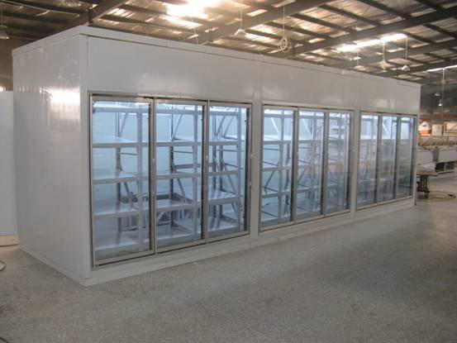
- Order only what is required for the service periods
- Rotate stock FIFO; as new stock comes into the kitchen it is best practice to use old stock before opening new stock.
When supplying large functions that go beyond the normal storage capacity it may be more cost efficient for extra cold storage to be rented just for the function time.
- Mobile storage cool rooms are ideal for this purpose.
When receiving stores it is always recommended to remove old stock before placing new stock into storage, replacing old stock back after allows for good stock rotation practices.
- If the supplier is amicable it is best to receive stores at a time when the restaurant is not busy
- This allows for the staff to attend to storage requirements without slowing production
- Quality points, such as appearance, colour, gills, eyes, odour and scales.

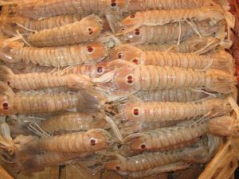
Lobsters and crayfish
Crustaceans, such as jointed limb and hard exterior shell can be sold as whole units.
When only the meat is needed in the dish the shells can be used to make sauces to flavour other dishes.

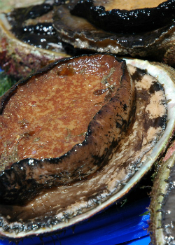
Molluscs
Molluscs like mussels, clams, vongole and oysters in shell will not require much trimming.
Care needs to be taken to ensure that dead stock is not sold to public
Meat only is available and can be more convenient to use. Care is still needed to check quality of meat before cooking.
Abalone
Abalone can be purchased:
- Live
- Meat fresh, vacuum packed
- Meat frozen, vacuum packed
- Canned.
Abalone has only about 35% yield.
To View website on how to clean abalone along with useful recipes –
http://www.diver.net/seahunt/abalone/abalone.htm.
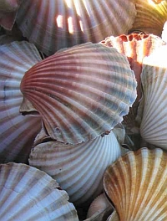
Scallops
Can be purchased in the shell when in season but fresh vacuum packed meat and frozen meats are available all year round.
Trimming may need to take place to clean meat; roe may need to be removed.

3.3 Identify and use correct equipment

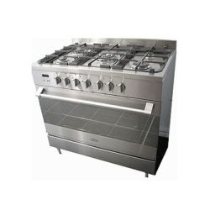
Introduction
Equipment may include:
- Electric, gas or induction stoves
- Steamers, such as pressure, atmospheric, bamboo and fish kettle
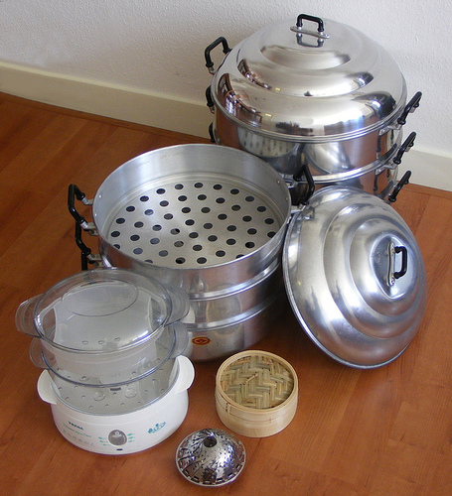
- Salamanders
- Smokers
- Grills, such as flat top, char and barbeque (BBQ)
- Ovens, conveyer ovens and combination ovens
- Deep fryer, such as pressure fryer
- Microwave
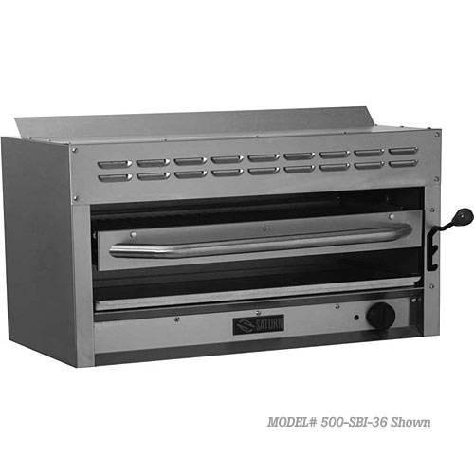
- Food processors, mixers, mincer and bowl choppers
- Drum sieve and strainers
- Utensils.
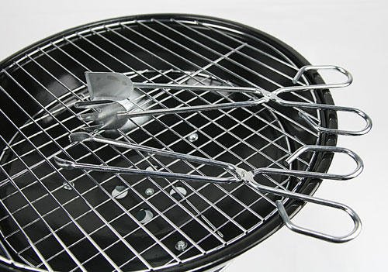

3.4 Hold and kill live seafood humanely and to regulations

Introduction
Storage equipment
Storing live fish and crustacean for customers to eat seafood will need special requirements in form of special equipment.
Tanks
Tanks will need to be clean at all times. Several tanks may be required for two separate species that prey on each other in the wild.
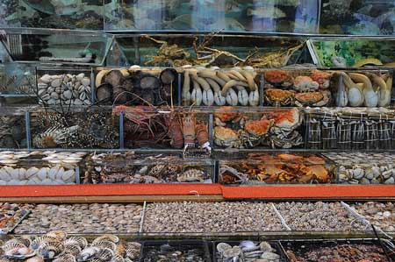
These tanks will need water filtration systems, water temperature control systems, the ph of the water needs to be monitored and a cleaning system will need to be put into place to keep tanks pristine.
Sign of poor water quality is froth on top of water, slime and algae growing on walls of tanks and unclear water.
These tanks cannot be overcrowded and each species need to be able to move about inside the tank.
Enterprise and government legislation
Killing of live seafood needs to be done expertly and humanely.
Live fish
Remove from the water using stress free methods and kill immediately. Upon killing the fish will need to be bled as quickly as possible.
Methods of killing fish
- ‘Pithing’: Hitting between eyes with small club or ‘priest’. This may require practise as one blow may not be sufficient
- ‘Ike Jime’; Japanese name for spiking into the brain and moving spike around to destroy brain. This also needs to be practiced as brain is small and can be missed.
Once spiked the fish is bled out by cutting the gill rakers then eviscerated as quickly as possible.
Killing live crustacean
Placing into freezer for 20 minutes to stun the animal then spiking into the brain. Only after this step, can the tail be separated from the head.
Killing crabs; inserting a spike into the head of the crabs between the eyes.

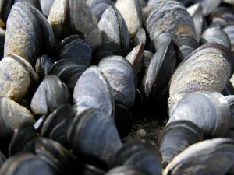
Storing Seafood; Crustacean and Molluscs out of water
Live Mussels
Store in containers that can be covered or in hessian bags that can be kept moist off the floor. Store in hessian bags and cover bags with ice is best rather than cool room.
Temperature of 5ºC – 10ºC for up to 3 days.
It is best to use as soon as possible. If storing live keep batches separate.
Live Abalone
Store in clean containers; keep moist in cool temperature for up to 4 days.
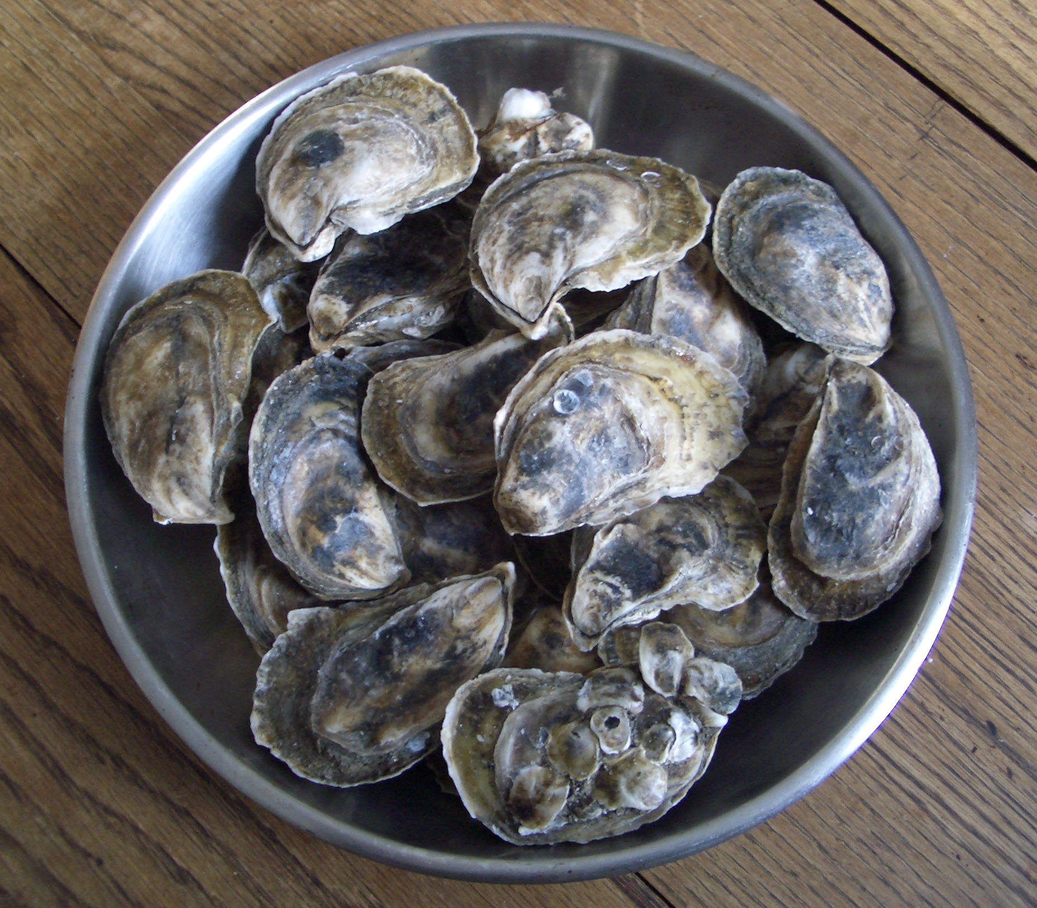
Oysters
Store live in special containers off the floor with wet hessian covers.
Different species last longer.
Sydney Rock last 8 to 9 days at 5ºC – 10ºC.
Pacific oysters last up to15ºC for 4 – 6 days.
These are live unshucked oysters. When shucked they must be chilled.
Rock Lobster
Do not last long out of water, maybe 6 hours.
Temperature Southern Rock 6ºC –10ºC
Tropical Rock lobsters 20ºC – 25ºC.
The warmer the breeding waters the warmer the outside of water storage temperature.
Process as soon as possible to prevent changes in flavour due to adverse conditions
Freshwater crayfish
Both yabbie and marron will live for 2 to 3 days at temperature of approximately 12ºC – 20ºC. Marrons have been known to travel overland to fresh water holes.
Need to keep moist with hessian bags and keep in dark environment and contained to prevent escapes.
The cooler the environment the less active they are but if too cold they will die.

Crabs
Mud crabs can live up to 3 days outside water with temperature 16ºC– 24ºC. Keep claws tied as your fingers can be at risk when handling untethered mud crabs.
Other crabs like blue swimmers do not last long outside water.
Information sourced from Guidelines on aquatic animal welfare for the aquaculture industry in Western Australia: Simon Bennison: ACWA Welfare Guidelines
Storing fish and shellfish
All other produce will have been processed before it enters your enterprise.
Storage of shelled and unshelled flesh will be the same.
Store at less than 5ºC for 3 days or less; what does your Food Safety Plan state?
If frozen the storage must be less than minus18ºC for up to 3 months.
Store in separate clean containers
If vacuum sealed they must still be stored in separate containers as there is possibility that seal will break causing cross contamination.
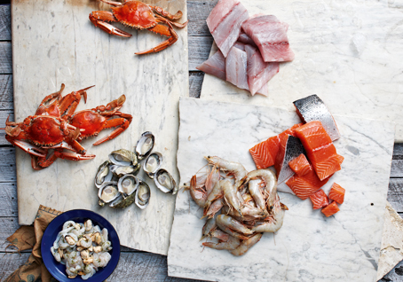
Work Projects
It is a requirement of this Unit you complete Work Projects as advised by your Trainer.
You must submit documentation, suitable evidence or other relevant proof of completion of the project by the agreed date.
The student needs to submit a plan or a report on the following requirements that are listed here and through the manual.
The student will need to produce a suitable number of dishes to prove that the leaning elements can be met.
Suggest that 6 seafood dishes are completed.
3.1 How will the fish variety be cleaned and portioned?
- Give written details of what is required for the cleaning, gutting and portioning.
3.2. How will off-cuts be utilised to minimise cost of ingredients?
3.3. Give a list of all equipment that will be required in the cleaning and portioning:
- Be sure to include and occupational health and safety equipment that will be needed when using specialist equipment.
3.4 If purchasing live seafood the following will have to be proven?
- How you plan to keep the seafood alive for the period of time that you will need before killing?
- What conditions need to be implemented to keep produce in stress free environment?
- Killing:
- How the killing process is to be implemented humanely?
- What happens to the seafood immediately after killing?

Summary

Prepare fish and shellfish
Prepare and portion fish and shellfish products to enterprise requirements
- Expert staff can prepare to enterprise requirements more efficiently than badly trained staff
- Portioning whole fish will lead to having wastage and offcuts; having menu items that use these ‘offcuts’ will improve profitability of enterprise.
Minimise wastage/trimmings through appropriate preparation and storage
- Skill of the staff can minimise waste allowing for greater profitability
- Properly stored frozen seafood allows for easing thawing and less waste
- Purchasing seafood already cleaned and trimmed saves time and is more efficient use of staff.
Identify and use correct equipment
- Each piece of equipment has specific role
- Each can add different flavour to ingredient
- Knowledge on how each piece is to be operated is imperative.
Hold and kill live seafood humanely and to regulations
- Keep storage areas clean and maintain water quality
- Do not mix species that may prey on each other
- Killing must be quick and humanely by expert practitioner.

Element 4:
Cook and present seafood

4.1 Select appropriate cooking method to fish variety and cuts

Introduction
Cooking method may relate to:
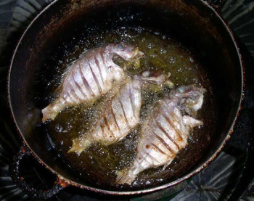
- Poaching for paupiette (small rolled fish fillets bound with flavoured farce)
- Poaching of whole fish
- Steaming for delice or whole fish
- Grilling for supreme or smaller fillets
- Baking for whole or portions wrapped in pastry
- Braising for a darne (portion)
- Deep and shallow frying, for goujon.
Other methods appropriate to cultural style:
- Wrapped in banana leaves with aromatics for example.
Saltwater and freshwater fish is enjoyed around the world. Most species can be cooked a variety of ways.
Some are suited to gentle forms of cooking like poaching and steaming due to their delicate flesh.
Variety in cooking styles gives flavour and textural diversity to the flesh.
Fish can be cooked poached and that is that. So why is not everything just poached.
Deep-frying give a different flavour to the same food
Contained inside the protective batter the fish is actually steamed while the batter becomes crisp and adds crunch to the food that would otherwise be softer.
The batter also holds in more of the natural juices of the fish which would normally be lost into the poaching water.
Seasoning and aromatics added to outside of flesh is not damaged by the high heat of the frying medium and retains more flavour to be enjoyed by the consumer.
So what is the best way to cook each variety?
Every culture has slightly different methods to cook the same product with different results.

4.2 Prepare and cook following standard recipes within a commercial environment

Darne of Fish Meuniere
Ingredients:
Fish
2 x 180gm Fish Darne
15 ml Oil
Seasoning
Sauce Meuniere
40 gm Butter
30 ml Lemon Juice
3 Lemon Slices
3 gm Parsley (chopped fine)
Method:
- Clean and season fish darne. Melt butter and oil in a pan. Cook darne 3 minutes each side (approximately) or until flesh just separates from the bone
- Place fish on hot a serving plate, with lemon slices, and keep warm
- Remove excess oil from pan. Add butter and cook to nut-brown colour. Add lemon juice then parsley while shaking the pan to slightly emulsify. Pour over the fish, from which bones have been removed
- Serve immediately.

Fish Mousseline Farce
Ingredients:
150gm Fish Fillets
1 Egg White
50 ml Cream
Trace Seasoning
Method:
- Chop fish flesh into pieces, place in a food processor and blend a little
- Add egg white and seasoning, blend until smooth (DO NOT OVERWORK)
- Last fold in cream over ice and flavour with 10g of chopped herbs of your choice.

Baked Supreme of Fish with Capsicum Puree
Ingredients:
Fish
180 - 200 gm Fish Fillets
15 ml Oil
1/4 tsp Black cracked pepper
1/4 tsp Cumin
1/4 tsp Coriander
1/4 tsp Turmeric
1/4 tsp Paprika
1/4 tsp Salt
Capsicum Puree
1 Red Capsicum (roasted and peeled)
Salt and Pepper
20ml Olive Oil
50ml Fish Stock
Cornflour
Method:
- Cut supreme to size and score skin
- Generously coat both sides with seasoning mix
- Cut capsicum in half and remove seeds, puree in food process with olive oil
- Place puree in a pot and add stock, bring to boil and slightly bind with corn flour. (This stops the puree from bleeding on a plate)
- Place supreme in a very hot pan skin side down, when charred turn over and place in an oven and bake for about 3 - 5 minutes at 180°C
- To serve spread capsicum puree in the middle of a plate, put supreme on top skin side up and garnish.

Tempura Batter
Ingredients:
50gm Flour
50gm Corn flour
Salt to taste
200ml Water (iced)
Method:
- With a fork combine dry & wet ingredients taking care not to over work (a few lumps are acceptable)
- Dust items lightly with corn flour
- Dip in batter and deep fry at 180°C.
Tempura Dipping Sauce
Ingredients:
25 ml Soy Sauce
1/4 tbsp Lime Juice
1/4 tsp Grated Ginger
1 tsp Chopped Coriander
1 tsp Sugar
Method:
- Combine all ingredients
- Refrigerate.

Paupiettes of Flounder Vin Blanc
Ingredients:
2 Flounder Fillets
25gm Onion (finely diced)
100ml White Wine
250ml Fish Stock
30ml Cream
30gm Butter
Method:
- Season fillets and spread with farce, roll up and pin with toothpick. (Remember skin side in)
- In a saucepan sweat onion in 10gm of butter, (DO NOT colour) deglaze with wine and add stock
- Bring to boil, turn down to poaching temp. (95°C)
- Remove 50ml of liquid stock and reserve for sauce
- Place the paupiettes into the hot stock and cover with a cartouche and cook for approximately 8 minutes.
To finish sauce
- As the paupiettes are cooking, combine cream and reserved fish stock liquid in a small pan and reduce by 1/2
- Remove from the heat and whisk in 20gm of cold butter.
To plate
- Remove fillets from the poaching liquid
- To serve place paupiettes on a plate, nappe with sauce and garnish.

Poached Fish Fillet Delice with Warm Vinaigrette
Ingredients:
2 Flounder Fish Fillets
30 gm Fish Farce
Court Bouillon
20 gm Onion
20 gm Carrot
20 gm Leek
1/2 Lemon
1 Bay leaf
Salt pinch
500 ml Water
Vinaigrette
40 ml Olive Oil
20 ml Vinegar
1/2 Lemon
Salt & Pepper
Salsa
50 gm Cucumber
50 gm Tomato
Herbs for garnish
Method:
- Prepare fish fillets
- Fold the tail of the fillet in with the farce in the fold and place in a fridge
- Prepare Court Bouillon and simmer for 20 minutes
- Mix vinaigrette and set aside
- Cut and dice cucumber and tomato, add some olive oil and season
- Poach delice until cooked
- Warm the vinaigrette
- Place fish on a plate, nappe with warm vinaigrette and serve accompanied with salsa, garnish.

Delice of Flounder
Ingredients:
2 Flounder fillets
15 ml Oil
Seasoning
Method:
- Fold Fillets to required shape
- Oil tray place fish on top
- Brush with oil and season
- Place under salamander
- Remove when done
- Place into Thai dressing
- Let fish infuse approximately 5 minutes
- Serve warm.
Thai Dressing
Ingredients:
25 ml Stock syrup
10 ml Fish sauce
10 ml Rice wine vinegar
25 ml Lime juice
1 clove Garlic, chopped
To taste Chilli, chopped
To taste Sea salt
To taste Black pepper
Method:
- Mix all ingredients together.

Whole Baked Flounder filled with Chilli Lemon and Chive Butter
Ingredients:
Flounder
1 Whole Flounder
Flour for Dusting
Oil
Butter:
60gm Butter
1 Small Chilli
1/4 Lemon Juice and Zest
Finely chopped Chives
Seasoning
Method:
Flounder
- Clean flounder as per demo
- Place oil and small amount of butter into baking tray and melt
- Flour flounder and coat in oil and butter mix
- Place in oven approximately 200°C
- When ¾ cooked fillet fish and remove centre bones
- Fill cavity with prepared butter
- Place under salamander and finish cooking.
Butter
- Prepare the compound butter from chilli, chives, lemon juice and seasoning. Shape into cylinder shaped piece
- Refrigerate.

Fish Quenelles with Tarragon Beurre Blanc
Ingredients:
Panada
35 ml Water
5 gm Butter
15 gm Flour
Farce
250 gm Fish Fillets
1 Egg White
30 ml Cream
To taste Salt & Pepper
For poaching
1 Litre Fish Stock
Beurre Blanc
90 gm Unsalted Butter
40 ml Fish Stock
40 ml White Wine
40 ml White Vinegar
5 gm Tarragon
To taste Salt & Pepper
Method:
Panada
- Bring water and butter to boil. Add flour and cook until mixture leaves sides of the pot
- Spread on a sheet of plastic wrap and wrap up, let cool (this stops a skin forming).
Quenelles
- Clean fish - remove any bones and sinews and bloodline
- Chop fish flesh into pieces, place into a food processor and blend a little, next add the panada, egg-white, and season and blend until fine and smooth, then pass through a sieve
- Next place into a bowl over ice, gradually add the cream, beating thoroughly with a wooden spoon, and chill in a fridge for 1 hour
- Mould the mixture between two spoons and place on a lightly oiled greaseproof paper
- Poach quenelles in fish stock, drain thoroughly and serve with the hot Beurre Blanc.

Beurre Blanc
- Cut butter into small cubes
- Reduce stock, wine, vinegar and tarragon stalks to approximately 20 ml (1 tablespoon)
- Strain reduction and transfer into stainless steel bowl, place over bain-marie
- Slowly add butter whisking vigorously taking care to maintain a constant temperature between 75°C & 80°C
- To serve add chopped tarragon leaves
- Napped over the quenelles.

Thai Fish Cakes
Ingredients:
200gm Boneless white fish fillets, roughly chopped
1/2 tbsp Thai Red Curry Paste
1 tsp Palm Sugar grated
1 tsp Fish Sauce
1/2 tbsp Tamarind Water
2 Kaffir Lime Leaves, chopped finely
80 gm Green Beans, thinly sliced
1/4 Red capsicum, cut into a small dice
Method:
- Place fish in food processor with paste, sugar, fish sauce, and tamarind water
- Pulse in processor until smooth
- Place in a bowl over ice
- Add lime leaves beans and capsicum mix well.
- Divide mix into small balls and flatten
- Leave to rest
- Shallow fry in oil 2-3 min each side until golden brown
- Drain and serve with dipping sauce.
Dipping Sauce
Ingredients:
75gm Castor Sugar
60ml White vinegar
1 Large Red Chillies, de-seeded and finely chopped
1 Small Piece Cucumber, de-seeded and finely chopped
5 gm Ginger, finely chopped
1 sprig Coriander finely chopped
Method:
- Place sugar and vinegar into a pan and reduce making sure sugar has dissolved
- Simmer for approximately 5 minutes or until slightly thickened
- Remove from heat and refrigerate
- When cold add cucumber and chilli
- Serve with fish cakes.

Fish Terrine with Basil – Nori
Ingredients:
350 gm White Flesh Fish
80 gm White Bread (fresh, no crust)
1 Egg white
60 ml Cream
1 Shallots (chopped)
Pinch Nutmeg
Pinch Mustard Powder
To taste Salt and Pepper
1 x Sprig Basil
20ml Cream (for adjusting)
2 Nori Sheets
Method:
- Soak the bread with 60 ml of cream and egg white
- Sweat the shallot off in a little butter and allow cooling
- Clean fish - remove any bones and sinews and bloodline, reserve a strip of cleaned fish for a centre garnish
- Chop fish flesh into pieces, place into a food processor and blend a little, next add the panada (bread, cream & eggwhite mix) season with nutmeg and mustard powder and blend until fine and smooth
- Do this in 2 batches
- Remove mix from the food processor and place into a bowl over ice, correct consistency with remaining cream
- Pass through a sieve
- KEEP COOL
- Spread some farce onto a piece of nori, place the reserved seasoned fish strip on top and wrap it up
- Divide the mixture into two lots – flavour one with basil and shallots and the other with tomato paste and shallots
- Place plastic wrap on bench with a piece nori on top
- Place one lot of farce down the centre of nori
- Place the nori wrapped strip on top and press down half way into farce, cover with the other flavoured farce
- Roll the terrine with overlapping nori and plastic wrap
- Tie up ends and remember to keep as round as possible
- Poach in water for approx 20 mins
- Cool and Serve.
Note: To add variety, shellfish such as scallops, prawns and mussels can be arranged in layers in the terrine or mixed into the farce.

Prawns with Zucchini, Chilli, Ginger and Coriander
Ingredients:
6 Prawns
5 ml Oil
3gm Chilli Paste
6 gm Fresh Ginger (chopped)
2 White of Spring Onion (sliced)
80 gm Zucchini (thinly sliced)
50 gm Red Capsicum (thinly sliced)
100 ml Prawn Stock
Squeeze Lemon Juice
3 gm Parsley (chopped)
3 gm Coriander leaves and Roots (chopped)
Method:
- Shell and de-vein the prawns, place in a bowl season, add a squeeze of lemon and spread with chilli paste
- Keep the shells and make a prawn stock (slightly thicken the stock with cornflour)
- Heat the oil in a frying pan and sauté the ginger, coriander roots and spring onion without colouring
- Add prawns and ¾ cook them
- Next add the zucchini, and then sliced capsicum and sauté for approximately 1 minute then add prawn stock
- Simmer for a short time until the stock is slightly reduced (not too thick)
- Add the lemon juice, parsley and coriander leaves and correct seasoning
- Arrange the vegetables on a plate place the prawns on top, sauce and garnish.

Salt Pepper and Chilli Calamari with Capsicum Salad
Ingredients:
Dressing
½ Chilli, cut in half lengthwise
100 ml Rice wine vinegar
30 gm Castor sugar
⅛ Lime juice
Seasoned Flour
40 gm Plain flour
40 gm Corn flour
1/2 tsp Sea salt
1/4 tsp Ground chilli
1/4 tsp Ground Szechuan pepper
1 Egg White
Salad
150 gm Calamari
1/2 Chilli
10 gm Red Capsicum
10 gm Yellow Capsicum
10 gm Green Capsicum
1 Piece Cucumber
1/4 Red Onion
1 Piece Carrot
Garnish
Coriander, fresh leaves
Method:
- Prepare the dressing by placing in a saucepan the chilli, vinegar and sugar. Heat until the sugar dissolves and simmers until the mixture has reduced to a thin syrup consistency. Add the lime juice. Strain and cool
- Mix together all the ingredients for the seasoned flour except egg white and set aside
- Score the calamari and set aside
- Prepare a fine julienne of the capsicum, chilli, red onion, cucumber and carrot
- Flour Calamari then dip in egg white then re-dip in flour
- Deep fry the squid until light golden brown and crisp. Drain well
- Dress salad, place on plate
- Place squid on salad while is still hot and crisp. Garnish with the coriander.

Mussels with Leek Thyme Tomato and Garlic Sauce
Ingredients:
15 gm Butter
20 gm Onion, finely diced
2 clove Garlic, crushed
1/4 Leek
1 Tomato
50 ml White wine
6 Mussels
3 Sprigs of Thyme
Seasoning
Method:
- Prepare a tomato concassé from the tomato
- Melt the butter in a pan, add the finely diced onion and crushed garlic cook over a low heat until soft
- Add the tomato with salt and pepper. Simmer for about 1 minute
- Next place a heavy bottom pot on stove to get hot
- Add the washed and prepared mussels with white wine 2 sprigs of thyme and julienne of Leek cook for approximately 3 – 4 minutes with a lid on
- Add concassé and heat through
- Arrange in a bowl with the sauce napped over the top and garnished with the remaining thyme.

Smoked Trout Pate with Dill
Ingredients
½ Smoked Trout
60 ml White Wine
100 ml Water
1 leaf Gelatine (soaked in cold water)
30 gm Butter (soft)
100 ml Sour Cream
2 gm Dill (chopped)
To taste Salt and Pepper
Method
- Remove skin and bones from the trout. Place flesh aside
- Place skin and bones (including the head) with water and wine in a pot, simmer to create a stock, and reduce
- Strain the stock and while still hot place 30 ml in a bowl, then dissolve the soaked gelatine leaf in it
- Place trout flesh in a food processor, add butter and dill, blend until smooth while adding the stock, and next lightly blend in the sour cream taking care not to curdle the mixture.

Chemise Jelly
Prepare 400ml of jelly using 7 gelatine leaves (use this between 4 students)
Ingredients
300 ml Water
100 ml Wine, white
Pinch Salt
7 Gelatine leaves
Method
- Soak gelatine leaves in cold water to soften
- Warm the water and wine and pinch of salt then add the gelatine leaves
- Dissolve gelatine then cool mixture
- Freeze metal dariole moulds or place into ice tray to chill
- When jelly has cooled and almost setting, pour some into mould and chemise the mould
- Place mould back into ice to firm and hold jelly
- Refer to the demo by instructor for this, decorate with some dill then fill with pate and set in a fridge and allow to set
- Turn out onto a plate, can be served with melba toast, grilled focaccia etc.
Chemising is a French term meaning ‘to lightly coat’.

Crab, Mussel and Calamari a La Grecque
Ingredients
1 Blue Swimmer Crab
50 gm Calamari
3 Green Lip Mussels
75 ml Olive Oil
30 ml White Wine
Squeeze Lemon Juice
25 gm Shallots (finely diced)
40 gm Tomato Concassé
1 tsp Coriander Seeds
1 tsp Parsley (chopped)
Trace Salt
Trace Pepper
2 Chives
1 Lemon Wedge
Method
- Cook the crab in boiling, salted water for about 5 mins (this will cook the legs and claws, but the inside will not be cooked through). Refresh the crab in cold water, then pull off the claws and legs, crack open and remove the flesh. Carefully remove the upper shell and clean thoroughly, set aside. Remove the half cooked flesh from the body, set aside
- Remove the head from the body of the calamari. Thoroughly clean the body inside and out under running cold water. Cut the tentacles from the head and discard the head. Wash the tentacles, cut body and tentacles into strips, and set aside
- Remove the mussels from their shell, wash and cut in half
- Heat oil in a fry pan, add shallots and sweat
- Add mussel and stir, then add calamari and tomato and toss
- Add wine, lemon juice and coriander seeds
- Add crabmeat, stir then remove from heat
- Stir in chopped parsley and season to taste, and leave to marinate
- The 'a la grecque' should be served at room temperature. Arrange the mixture on a plate, and garnish with the cleaned shell, lemon wedges and chives.

Squid and Scallops in Thai Dressing
Ingredients
3 Scallops
3 pieces Squid (cut into triangle and scored)
30 ml Lime
3 gm Chilli Paste
¼ Lemon Grass (crushed)
3 ml Fish Sauce
60 ml Peanut Oil
15 gm Palm Sugar
5 gm Garlic
30 ml Coconut Milk
5 gm Vietnamese Mint (chopped)
To taste Salt
Method
- Mix all ingredients for marinade together and let sit for at least one hour before use
- Clean scallops, cut and score the squid
- Char grill scallops and squid on a hot grill taking care not to overcook
- Place them hot in the marinade; serve when cold remembering to remove the lemon grass prior to serving.

4.3 Hold prepared products as required prior to presenting

Introduction
Holding prepared products before service can be applied to two areas:
- Hot food
- Cold food.
Holding prepared cooked food requires food to be held at temperatures above 60°C until it is served to customers.
Holding food cold at safe temperature until required for service requires that food be held at temperature of less than 5°C until required.
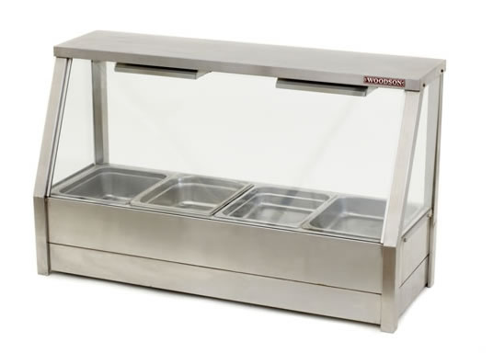
If food is held outside of these temperatures then the 2 hour 4 hour rule needs to be activated.
If outside of temperature control for more than two hours, food must be consumed or discarded.
To hold foods above 60°C, the bain-marie must be operating at 80°C and the food must be covered.
If the bain-marie is not operating at this temperature then the food will not be at above 60°C and the process will have to be rectified.

4.4 Present fish and shellfish, including slice/carve and portion size

Introduction
Presentation of all dishes is the same in all countries.
Using the natural attributes of the product to make it appealing to the eye of the customers.
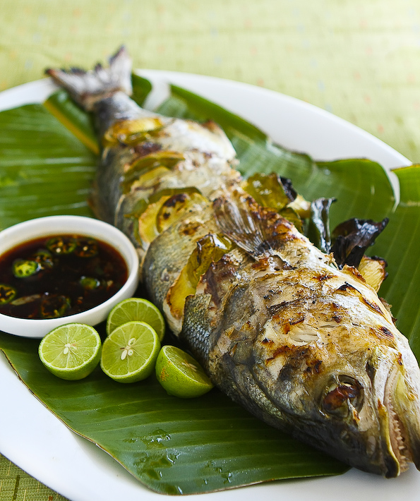
Whole fish and Whole Crustacean
Whole fish served on a platter can either be lying on side or standing up.
If presenting with the head on it is advisable to present standing up position.
The fish may have to be moulded so it site better on plate.
This moulding is done before cooking so that the set shape is manipulated while there is some flexibility in the flesh.
Set on baking tray with props that will put bend into fish so shape is kept when it is cooked:
- Shape of half moon is best.
When placed onto platter it will have a 3 dimensional aspect to the dish:
- Garnish with desired garnish; lots of colour for effect.
Whole crustacean will have a dramatic colour change when cooked and contrast colour match the vibrant RED is GREEN.
Garnishes coloured yellow adds extra contrast and eye appeal to the show.
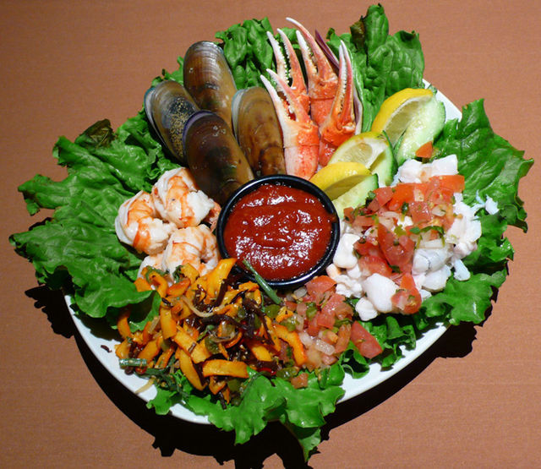
Fish and seafood portions
Single serves of seafood and fish are best served flat on plate with minimal garnish.
Garnish - sauce and accompaniment to compliment the base ingredient on plate.
As with all food presentation it should be neat and any excess sauces need to be cleaned of the plate or platter.

4.5 Prepare garnishes, sauces and accompaniments for fish and shellfish dishes
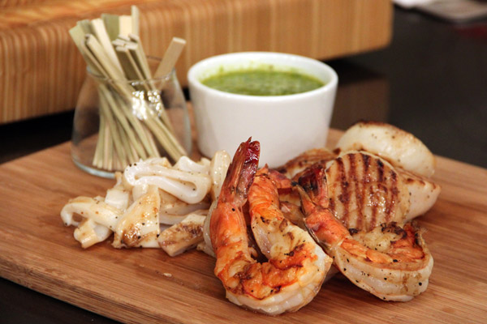
Sauces for seafood dishes can be served on the side or as an accompaniment.
Cutlets and supremes served on platter in single serves will have a sauce served on the plate with the meat.
Whole fish served on platters will be decorated or garnished with fresh herbs and fruits suitable to the flavour of the cuisine used to flavour the fish.
Whole fish can be served standing up or lay on side.
Chef will make the decision on how the final presentation will look.
Fish is sometimes cooked 'en paplliote'; in parchment or in banana leaf. This is in effect steaming and the juices produced will be the sauce that is served with the fish.
The parchment is sometimes pastry and then the casing of pastry becomes the decoration of the fish and is consumed with the meal.
Garnishes that may be prepared for seafood; fish and shellfish:
- Sauces – hot and cold:
- Beurre blanc (hot)
- Cocktail sauce (cold)
- Vinaigrettes of various flavour and cultural enhancements
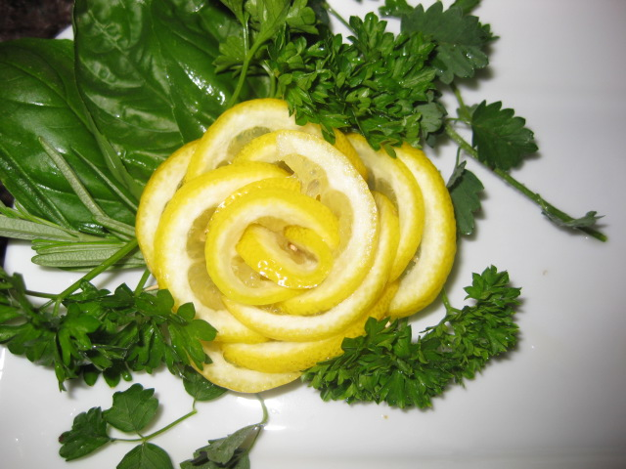
- Fresh herbs
- Fresh fruits
- Leaf salads
- Vegetables:
- Fried onions
- Julienne of capsicum; red; green; yellow.
Anything that adds eye appeal and compliments the base flavour of the main flesh.

Work Projects
It is a requirement of this Unit you complete Work Projects as advised by your Trainer.
You must submit documentation, suitable evidence or other relevant proof of completion of the project by the agreed date.
The student needs to submit a plan or a report on the following requirements that are listed here and through the manual.
The student will need to produce a suitable number of dishes to prove that the leaning elements can be met.
Suggested that 6 seafood dishes are completed.
4.1 Cooking methods will need to be listed; minimum 6 methods:
- Each dish needs to have a different cooking method applied
- Students need to be able to explain why this method is best for this cut or type of seafood
- Prepare and cook their selection of recipes
- When cooked how are the dishes going to be held before being presented for assessment
- Quality point of the dish needs to be in place when presented.
4.2 Student will need to prepare and cook a selection of garnishes and accompaniments of their choice for each dish:
- No two dishes can have the same garnish or accompaniments.

Summary

Cook and present seafood
Select appropriate cooking method to fish variety and cuts
- All fish can be cooked many ways
- Whole fish are best steamed or baked
- Smaller whole fish can be deep fried
- All the rest are best to grill or pan fry
- Most can steamed
- Celephopods are best quickly fried in shallow pan or long cooking braise.
Prepare and cook following standard recipes within a commercial environment
- Read recipe and collect all ingredients required
- Assemble equipment needed before proceeding.
Hold prepared products as required prior to presenting
Ensure that holding equipment is functioning properly to meet operational requirements of the enterprise and the enterprise Food Safety plan.
Present fish and shellfish, including slice/carve and portion size
- All seafood can be presented whole or portioned
- Requirements will be decided by chef of the kitchen.
Prepare garnishes, sauces and accompaniments for fish and shellfish dishes
- Prepare the required garnishes as outlined in the recipe
- Prepare and store to maintain freshness.

Element 5:
Store fish and shellfish to enterprise requirements

5.1 Fresh and/or Cryovac items are stored correctly

Introduction
Fish and shell fish are highly perishable commodities.
Fresh Live
Purchasing fresh live seafood requires the keeping of storage tanks and this requires special equipment to keep water clean and suitable for fish and shellfish to survive:
- Containers need to be of a size large enough for the seafood to move about freely
- Water quality needs to be monitored, cleaned and filtered.
- Records may need to be kept on water quality testing results
- Water will need to be kept aerated.
Poor water quality shows as:
- Slime on inside of tank wall
- Froth on water
- Unclear, cloudy water.
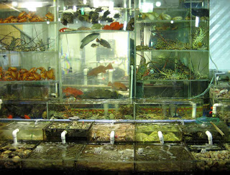
Fresh
Fresh need to be kept in clean containers as close to 0°C as possible for no more than 2 – 3 days.
Fish can be kept on ice but allowance has to be made for melting ice, allowing water to drain away:
- Flesh should not sit in water for extended periods
- Change storage trays daily
- Keep covered with clean damp covers.
Fresh mussels
Fresh Mussels are best kept in warmer part of cool room as close to 5ºC – 10ºC as they are still alive and if they get too cold they will die:
- They should keep 3 – 4days at this temperature
- Keep in moist hessian off the floor
- Keep hessian moist.
Live crabs
Do not keep well out of water; several hours.
Mud crabs will live for 1 – 2 days out of water but need warmer temperature of 15ºC –20ºC environment:
- Keep claws tied until death as they are easier to handle and prevents cannibalism
- Your fingers may suffer serious injury from a nip by a mud crab.
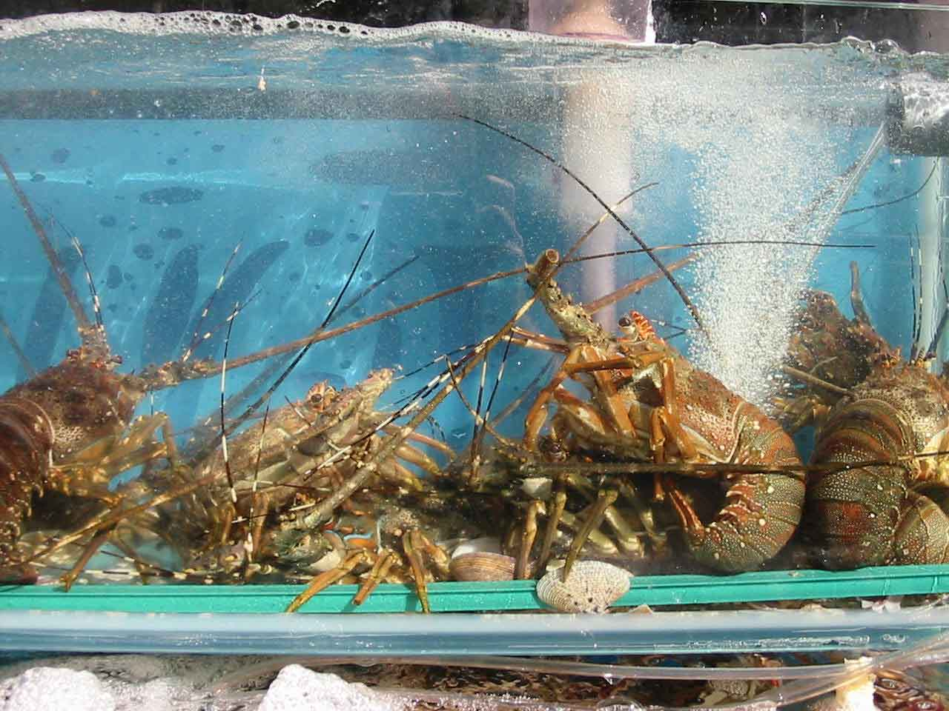
Crustaceans
Live lobster does not survive long out of water, maybe as little as 6 hours. Keep in water tanks if want to live longer. Freshwater crayfish may live up to 3 days out of water. Western Australian yabbies and marron are known to travel overland to other waterholes:
- Monitor temperatures; need to be about 12ºC – 20ºC.
Oysters
Oysters will live for up to 6 days out of water if kept moist under hessian that is moist.
Temperature approximately 5ºC –10ºC.
Sydney rock oysters will tolerate up to 15ºC for 8 – 9 days.
Vacuum Packaged Product
Vacuum packed product should be kept in clean trays that will be able to securely hold any liquid spills from sealed bag.
Should be in single layers to protect product from damage.
All seafood is best used as soon as possible after purchasing to minimise money held in stock and to serve product as fresh as possible to customers.

5.2 Prepare and maintain correct thawing of fish and shellfish

Introduction
Enterprise and local authority requirements will determine thawing procedures.
Food safety regulation say that the best place to thaw frozen fish and shellfish is in the cool room.
Seafood portions that have been cleaned, portioned and frozen in single layers will thaw quicker than thicker blocks of frozen product.
Place frozen product into a clean tray deep enough to hold any liquid that comes from the thawing.
Single layers will thaw within 24 hour in cool room at less than 5ºC. Larger sizes may take longer.
Change trays daily to prevent product sitting in excess water.
Use thawed product within one day of thawing.
5.3 Fish and shellfish are appropriately stored in correct containers

Introduction
Storage containers before assembly
- Containers used for storage of all seafood must be of quality suitable for the job
- Containers must be sound quality, not broken
- Must be clean.
Storage containers after assembly
Container must be able to be securely wrapped to protect product from contamination and a label must be able to be attached.
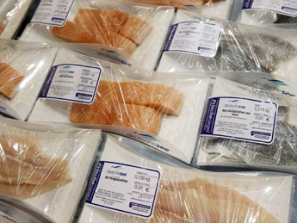
Labelled
- When stored product must be labelled with relevant information
- Dated and priority given to maintain freshness; FIFO
- Consideration of freshness, quality and presentation.
Temperature and humidity
Temperature needs to be at a level that will slow the deterioration to an acceptable level.
All cleaned and gutted product must be stored at close to 0ºC as possible for as little time as possible:
- 1 – 2 days
- Purchase only what is required for daily sales
- Humidity around 85% to prevent drying of unprotected product.

5.4 Fish and shellfish are correctly labelled

Introduction
All products
All product that is handled by the enterprise needs to be correctly labelled at all times.
With a large workforce it is easy to have all product labelled so everybody knows:
- What the product is?
- When it was made?
- Who made product?
- What is the ‘use by’ or ‘best before’ date?
Correct labelling minimises the possibility of accidents happening and keeps stock flow rotation going as it should.

5.5 Ensure correct conditions are maintained for freshness and quality

Introduction
Temperature and humidity
Correct temperature maintenance will prevent shortened lifespan of food.
Equipment needs to be checked on a regular basis to ensure it is operating efficiently and effectively.
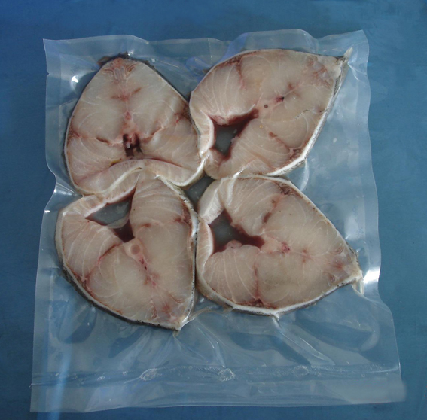
Stock rotation
Stock need to be dated when product comes into an enterprise so life can be monitored:
- First in and first out
- Keep stock to minimum and use old stock before new stock.
Reporting faults
If equipment is found to be not operating efficiently then it needs to be reported to supervisor and then to maintenance personnel for corrective action to take place.
Changing containers
When storing food for a period of time and with seafood especially it is important that containers are changed on a regular basis:
- Daily
Fish and seafood that has been placed on ice for preservation will need to have the melted ice water removed.
Lying in water affects the structure of the flesh and also is a breeding culture for bacterial build up.

Work Projects
It is a requirement of this Unit you complete Work Projects as advised by your Trainer.
You must submit documentation, suitable evidence or other relevant proof of completion of the project by the agreed date.
The student needs to submit a plan or a report on the following requirements that are listed here and through the manual.
The student will need to produce a suitable number of dishes to prove that the leaning elements can be met.
Store fish and seafood
Include in the report and also it will be identified in practical assessment that the following criteria are met.
5.1 How will the storing of vacuum sealed fish and seafood be implemented?
- Give specific instruction in relation to temperature, packaging conditions.
5.2. When frozen produce will need to be thawed?
- Give specific guidelines that will need to be followed.
5.3. Information on containers and labelling requirements.
- Be specific.
5.4. How will fish and seafood be maintained to peak freshness and quality?
- What needs to be in place for this to happen?

Summary

Store fish and shellfish to enterprise requirements
Fresh and/or Cryovac items are stored correctly
- Store Vacuum sealed (Cryovac) fish and shellfish in single layers
- Store fresh fish as close to 1ºC as possible
- Fresh fish should be stored eviscerated (Gutted)
- Store on trays that allow water to drain away to catching tray underneath
- Change storage trays everyday.
Prepare and maintain correct thawing of fish and shellfish
- When thawing fish and shellfish they should be stored in coolroom that is at a temperature of less than 5ºC
- Use thawed product as soon as possible
- Change storage trays everyday.
Fish and shellfish are appropriately stored in correct containers
- Storage containers must be in good conditions
- Food grade plastic or stainless steel is recommended
- Containers must be clean before using.
Fish and shellfish are correctly labelled
- Labels must be attached to all stored products
- Labels must include:
- Name of the product
- Date of storage
- Use by date
- Name of person who was processed the product.
Ensure correct conditions are maintained for freshness and quality
- Fish and seafood have a short life when stored as fresh product
- Store at a temperature as close to 1ºC as possible
- Cover with plastic and cover with crushed ice
- Allow water (melted ice) to drain away
- Frozen fish and seafood should be wrapped securely to prevent freezer burn
- Ensure labels are attached with correct information
- Rotate stored product with first in first out policy.

Presentation of written work

1. Introduction
It is important for students to present carefully prepared written work. Written presentation in industry must be professional in appearance and accurate in content. If students develop good writing skills whilst studying, they are able to easily transfer those skills to the workplace.

2. Style

Students should write in a style that is simple and concise. Short sentences and paragraphs are easier to read and understand. It helps to write a plan and at least one draft of the written work so that the final product will be well organised. The points presented will then follow a logical sequence and be relevant. Students should frequently refer to the question asked, to keep ‘on track’. Teachers recognise and are critical of work that does not answer the question, or is ‘padded’ with irrelevant material. In summary, remember to:
- Plan ahead
- Be clear and concise
- Answer the question
- Proofread the final draft.

3. Presenting Written Work
Types of written work
Students may be asked to write:
- Short and long reports
- Essays
- Records of interviews
- Questionnaires
- Business letters
- Resumes.
Format
All written work should be presented on A4 paper, single-sided with a left-hand margin. If work is word-processed, one-and-a-half or double spacing should be used. Handwritten work must be legible and should also be well spaced to allow for ease of reading. New paragraphs should not be indented but should be separated by a space. Pages must be numbered. If headings are also to be numbered, students should use a logical and sequential system of numbering.
Cover Sheet
All written work should be submitted with a cover sheet stapled to the front that contains:
- The student’s name and student number
- The name of the class/unit
- The due date of the work
- The title of the work
- The teacher’s name
- A signed declaration that the work does not involve plagiarism.
Keeping a Copy
Students must keep a copy of the written work in case it is lost. This rarely happens but it can be disastrous if a copy has not been kept.
Inclusive language
This means language that includes every section of the population. For instance, if a student were to write ‘A nurse is responsible for the patients in her care at all times’ it would be implying that all nurses are female and would be excluding male nurses.
Examples of appropriate language are shown on the right:
Mankind | Humankind
Barman/maid | Bar attendant
Host/hostess | Host
Waiter/waitress | Waiter or waiting staff

Recommended reading
Bailey, Adrian & Ortiz, Elisabeth Lambert; 2003; The book of ingredients, Michael Joseph
DK Publishing; 2011; Seafood; DK Publishing
Green, Aliza; 2007; Field Guide to Seafood; Quirk Books
Hobday.Cara; 2010; Food Presentation Secrets: Styling Techniques of Professionals; Firefly Books
Igoe, Robert S; 2011 (5th edition); Dictionary of food ingredients; Springer
McWilliams, Margaret; 2013 (10th edition); Food fundamentals; Pearson
McWilliams, Margaret; 2013 (11th edition;, Illustrated guide to food preparation; Pearson
Peterson, James; 1996; Fish & Shellfish: The Cook's Indispensable Companion; William Morrow Cookbooks
Scanlon.N; 2012 (4th edition); Catering Management; Wiley
Styler.Christopher; 2006; Working the Plate: The Art of Food Presentation; Houghton Mifflin Harcourt
The Culinary Institute of America (CIA); 2011 (9th edition); The Professional Chef; Wiley
The Culinary Institute of America (CIA); 2014 (4th edition); Techniques of Healthy Cooking; Wiley
The Editors of Seafood Business; 2009 (2nd edition); Seafood Handbook: The Comprehensive Guide to Sourcing, Buying and Preparation; Wiley
Thompson, Fred; 2006; The Big Book of Fish & Shellfish; Chronicle Books

Trainee evaluation sheet

Prepare and cook seafood
The following statements are about the competency you have just completed.
Please tick the appropriate box | Agree | Don’t Know | Do Not Agree | Does Not Apply
There was too much in this competency to cover without rushing.
Most of the competency seemed relevant to me.
The competency was at the right level for me.
I got enough help from my trainer.
The amount of activities was sufficient.
The competency allowed me to use my own initiative.
My training was well-organised.
My trainer had time to answer my questions.
I understood how I was going to be assessed.
I was given enough time to practice.
My trainer feedback was useful.
Enough equipment was available and it worked well.
The activities were too hard for me.

The best things about this unit were:

The worst things about this unit were:

The things you should change in this unit are:

Trainee Self-Assessment Checklist
As an indicator to your Trainer/Assessor of your readiness for assessment in this unit please complete the following and hand to your Trainer/Assessor.

Prepare and cook seafood
 |  | Yes | No*
Element 1: Identify and select fish varieties
1.1 | Identify a selection of fish varieties
1.2 | Identify commercial cuts of fish for menus
1.3 | Identify and select suppliers for purchasing of products
1.4 | Minimise wastage through correct purchasing
1.5 | Identify costs through yield testing
Element 2: Identify and select shellfish varieties
2.1 | Identify shellfish varieties
2.2 | Identify commercial cuts of shellfish for menus
2.3 | Identify and select suppliers for purchasing of products
2.4 | Minimise wastage through correct purchasing
2.5 | Identify costs through yield testing
Element 3: Prepare fish and shellfish
3.1 | Prepare and portion fish and shellfish products to enterprise requirements
3.2 | Minimise wastage/trimmings through appropriate preparation and storage
3.3 | Identify and use correct equipment
3.4 | Hold and kill live seafood humanely and to regulations
Element 4: Cook and present seafood
4.1 | Select appropriate cooking method to fish variety and cuts
4.2 | Prepare and cook following standard recipes within a commercial environment
4.3 | Hold prepared products as required prior to presenting
4.4 | Present fish and shellfish, including slice/carve and portion size
4.5 | Prepare garnishes, sauces and accompaniments for fish and shellfish dishes
Element 5: Store fish and shellfish to enterprise requirements
5.1 | Fresh and/or Cryovac items are stored correctly
5.2 | Prepare and maintain correct thawing of fish and shellfish
5.3 | Fish and shellfish are appropriately stored in correct containers
5.4 | Fish and shellfish are correctly labelled
5.5 | Ensure correct conditions are maintained for freshness and quality

Statement by Trainee:
I believe I am ready to be assessed on the following as indicated above:
Signed: | _____________________________ | Date: | ______ / ______ / ______
Note:
For all boxes where a No* is ticked, please provide details of the extra steps or work you need to do to become ready for assessment.





